Glossary Finance 3

CR01 3

PV01 3

DV01 3

Acceptances 3

Advanced Internal Ratings Based Approach (AIRB) 3

Antithetic variates 3

ALM 3

ALM Framework ING 3

ALM Gap report 3

Allowance for credit losses 3

Alt-A assets 3

Asset-backed securities (ABS) 3

Assets-to-capital multiple 3

Assets under administration (AUA) 3

Assets under management (AUM) 3

Auction rate securities (ARS) 3

Bank-owned life insurance contracts (BOLI) 3

Basel Capital Adequacy Return (BCAR) 3

Basis point bp 4

BLACK-SCHOLES formula 4

Canadian GAAP 4

Capital 4

Capital adequacy 4

Capital position 4

Comprehensive Capital Analysis and Review (CCAR) 4

Conditional VaR (CVaR) 4

Collateral 4

Collateralized debt obligation (CDO) 4

Collateralized loan obligation (CLO) 4

Commercial mortgage-backed securities (CMBS) 4

Commitments to extend credit 4

Covered bonds 4

Credit default swaps (CDS) 4

Credit Risk Adjudication 4

Credit Risk Creation 4

Credit Valuation Adjustment (CVA) 5

Credit VaR (CVaR) 5

Derivative 5

Dividend payout ratio 5

Dividend yield 5

Duration 5

Earnings per share (EPS), basic 5

Earnings per share (EPS), diluted 5

Economic capital 5

Equity Basket Option 5

Equity Risk 5

Equity Swap 5

Equity underwriting 5

Equity warehousing 5

Gross adjusted assets (GAA) 5

Guarantees and standby letters of credit 6

Harmonized sales tax (HST) 6

Hedge 6

Hedge funds 6

Home equity products 6

Impaired loans 6

Innovative capital instruments 6

Incremental risk charge (IRC) 6

International Financial Reporting Standards (IFRS) 6

Interest Rate Risk 6

Interest Rate Swap IRS 6

Liquidity Risk 6

Market risk sensitivities 6

Market risk types 6

Market Risk type (and risk factors) 6

Master netting agreement 6

Monte Carlo Simulation 6

Net interest income 7

Net interest margin (average assets) 7

Net Interest Income NII, Net Interest Margin, Non-Interest revenues 7

Normal course issuer bid (NCIB) 7

Notional amount 7

Potential Future Exposure PFE 7

Primary sources of risk 7

Productivity ratio 7

Off-balance sheet financial instruments 7

Office of the Superintendent of Financial Institutions Canada (OSFI) 7

Operating leverage 7

Options 7

Option-adjusted spread OAS 7

Portfolio run-off 7

Prepaid pension benefit cost 7

Primary dealer 7

Provision for credit losses (PCL) 7

RAROC Risk-Adjusted Return on Capital 7

Repurchase agreements 7

Residential mortgage-backed securities (RMBS) 7

Return on common equity (ROE) 7

Reverse repurchase agreements 7

Risk 7

Risk-weighted assets (RWA) 7

SCD Data Format Setup DFS 8

SCD Financial Accounting Methods FAM 8

SCD Financial Accounting Principles FAP 8

SCD Financial Scheme, Financial Account Assignments 8

Securities lending 8

Securities sold short 8

Securitization 8

Special purpose entities (SPEs) 8

Standardized Approach 8

Static P&L or hypothetical P&L 8

Stress test, scenario analysis 8

Structured investment vehicles 8

Subprime lending 8

Taxable equivalent basis (teb) 8

Tier 1 capital and Tier 1 capital ratio 8

Tier 2 capital 8

Total capital and total capital ratio 8

Tranche 8

Troubled asset workout 8

Trust Capital Securities (RBC TruCS) 8

Trust Subordinated Notes (RBC TSNs) 8

Value-at-Risk (VaR) 8

Variable interest entity (VIE) 9

FX Trading Private 9

Data Management 10

Data Management Maturity 10

DARPA data management framework 10

Data Management 11 Knowledge Areas 10

Data Management Context diagram 10

Data Governance Context Diagram 10

Data Architecture Management 11

Data Development Context Diagram 12

Data Operations Management 12

Data Security Management 13

Reference and Master Data Management 13

Data Warehousing & Business Intelligence Management 13

Document and Content Management 14

Meta Data Management 15

Data Quality Management 15

Service Management 16

ITIL Infrastructure 16

ITIL Strategic questions 17

ITIL v3 17

Service Design 17

Service Design Scope 17

Service Design Big Picture 18

Service Portfolio, Service Catalogue 18

Service Level Management 19

Capacity Management 19

Availability Management 20

Service Continuity Management 20

Information Security Management 21

Service Delivery 21

Microsoft Operations Framework (MOF) 22

IT Governance 22

FI 3 Lines of Defense 23

# Glossary Finance

#### CR01

Credit Spread Sensitivity (CR01) = change in market value for 1bp change in credit spread

#### PV01

**BPV (basis point value)** or **PV01 (present value of an 01)** are often synonym of **DV01**, although PV01 better refers to *the value of a 1 dollar or 1 basis point annuity*. For par bond and flat yield curve, DV01 (derivative of price w.r.t. yield) = PV01 (value 1$ annuity).

#### DV01

Dollar duration is derivative of the value with respect to yield



It is the product of the modified duration and the price (value):

DV01 = (Market Value + Accrued Income) x Modified Duration / 10,000

DV01 is analogous to the delta in derivative pricing (The Greeks) viz. the ratio of a price change in output (dollars) to unit change in input (a basis point of yield). Dollar duration or DV01 is the *change in price in dollars*, not in percentage. It gives the dollar variation in a bond's value per unit change in the yield. It is often measured per 1 basis point - DV01 is short for "*dollar value of an 01" (or 1 basis point)*

#### Acceptances

Bill of exchange or negotiable instrument drawn by borrower for payment at maturity &d accepted by a bank; acceptance constitutes a guarantee of payment by the bank and can be traded in the money market; bank earns a “stamping fee” for providing this guarantee

#### Advanced Internal Ratings Based Approach (AIRB)

A measurement of credit risk under Basel II that uses risk weights determined from internal risk parameters, including probability of default, loss given default and exposure at default

#### Antithetic variates

The antithetic variates method is a variance reduction technique used in Monte Carlo methods. Considering that the error reduction in the simulated signal (using Monte Carlo methods) has a square root convergence (standard deviation of the solution), a very large number of sample paths is required to obtain an accurate result.

#### ALM

Range of assets, liabilities, off B/S items •Liquidity risk and interest rate risk in Basel II Pillar 2 banking book requirements •Reports (static and dynamic interest rate and liquidity gap reports, beta gap reports, duration and convexity reports) •Tools (dynamic B/S income simulation, EaR, CFaR, VaR, market value sensitivity analysis) •IAS 39/FAS 133 prospective testing •Matched-maturity funds transfer pricing (FTP)

**ALM beta-adjusted gap reports** modified to mollify the errors caused by basis risk because all interest rates do not change by the same amounts, but there is correlation between changes in various interest rates. Some rates are more sensitive to change than other rates. In beta-adjusted gap analysis, the volumes of assets and liabilities subject to re-pricing are weighted to reflect the historical sensitivity of the yields or costs of those assets and liabilities relative to some benchmark yield or cost

**ALM maturity gap** stratify bank’s assets, liabilities and off-B/S instruments into maturity segments (time bands) based on instruments next re-pricing or maturity date. Balances within time band summed (assets as +ve amounts, liabilities as –ve amounts) to produce net gap position for each time band. Risk measured by size of gap (amount of net imbalance within time band and length of time gap is open) Off B/S $100M 5-year interest swap (receives fixed rate, pays 3-month Libor) reported as positive $100M in 5-year time band and negative $100M in 3-month time band; ‘long ‘fixed rate payment (owning fixed rate asset) and ‘short’ floating-rate payment (floating-rate liability)

* **Capital Management Regulatory** OSFI Tier 1 – Tier 2 risk-weighted assets (on/off B/S exposures + market risk exposures)
* **Capital** ❶**Legal** (common equity+preferred shares) >= **Target Regulatory** (capital adequacy measures for risk weighted assets) >= **Economic** (must-have net value at year start to ensure small probability of defaulting in that year) ❷**Required Capital** regulator’s assessed Bank’s risks ❸**Available Capital** regulator’s assessed banks assets minus liabilities according to accounting principles ❹**Capital Adequacy Ratio** CAR = [Tier I + Tier II Capital] / (8% * RWA) ❺**Economic Capital by risk type** Credit Risk, Debt Specific Risk (Credit VaR), Market Risk (VaR), Operational Risk, Strategic Risk (failure due to significant investments through acquisition/ growth), investment Risk (associated with Merchant Banking type securities), customer behavior risk (mortgages deviations from contractual cash flows due to customer prepayments, liquidations) ❻ **Economic Capital parameters** expected default frequency EDF (5 years historical data) EAD (70/80% of facility and current usage) LGD (by internal ratings) Time Horizon 1 year, Confidence Level 99.97%, Transition Matrix, Expected Loss ❼ **Total MR Capital** = General MR Capital + Specific Risk Capital + Incremental Risk Capital where general MR = risk of losses due to movements in prices/ volatilities, specific risk = risk of losses due to idiosyncratic factors related to individual issuer/obligor; product coverage debt securities (bonds, CD, CP, debentures), credit (CDS), derivatives, equity; correlations *significant* (credit migration/ default events of obligors) + *negligible* (credit migration/default events, systematic market risk factors); risk factors equity prices, equity volatility surfaces, interest rate curves, IR spread curves, caplet volatility surfaces, swaption volatility surfaces, FX rates, firm assets from which to determine defaults, bond spread curves, CDS spread curves; default and migration implied by asset model calibrated to transition matrices

#### ALM Framework ING

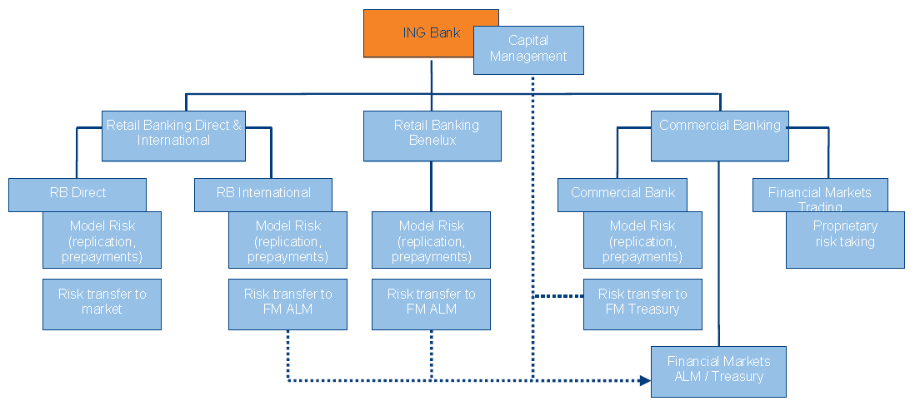

#### ALM Gap report

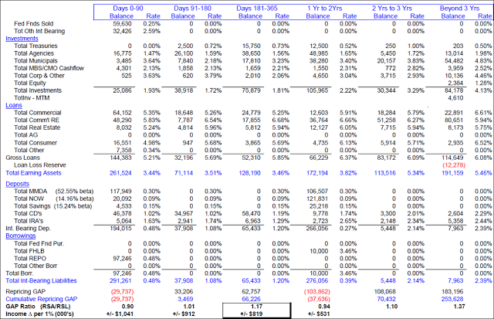

#### Allowance for credit losses

Amount deemed adequate to absorb identified credit losses as well as losses that have been incurred but are not yet identifiable as at the balance sheet date. This allowance is established to cover the lending portfolio including loans, acceptances, guarantees, letters of credit, and unfunded commitments. The allowance is increased by the provision for credit losses, which is charged to income and decreased by the amount of write-offs, net of recoveries in the period.

#### Alt-A assets

A term used in the U.S. to describe assets (mainly mortgages) with a borrower risk profile between the prime and subprime categorizations. Categorization of assets as Alt-A (as opposed to prime) varies, such as limited verification or documentation of borrowers’ income or a limited credit history.

#### Asset-backed securities (ABS)

Securities created through the securitization of a pool of assets, for example auto loans or credit card loans.

#### Assets-to-capital multiple

Total assets plus specified off-balance sheet items, as defined by OSFI, divided by total regulatory capital.

#### Assets under administration (AUA)

Assets administered by us, beneficially owned by clients, as at October 31, unless otherwise noted. Services provided in respect of assets under administration are of an administrative nature, including safekeeping, collecting investment income, settling purchase and sale transactions, and record keeping.

#### Assets under management (AUM)

Assets managed by us, which are beneficially owned by clients, as at October 31, unless otherwise noted. Services provided in respect of assets under management include the selection of investments and the provision of investment advice. We have assets under management that are also administered by us and included in assets under administration.

#### Auction rate securities (ARS)

Securities issued through special purpose entities that hold long-term assets funded with long-term debt, with an interest rate reset every week to 35 days via auctions managed by participating financial institutions. In the U.S., the securities are issued by sponsors such as municipalities, student loan authorities or other sponsors through bank-managed auctions.

#### Bank-owned life insurance contracts (BOLI)

Our U.S. Insurance and Pension solutions business provides banks with BOLI stable value agreements (“wraps”), which insure the life insurance policy’s cash surrender value from market fluctuations on the underlying investments, thereby guaranteeing a minimum tax-exempt return to the counterparty. These wraps allow us to account for the underlying assets on an accrual basis instead of a mark-to-market basis.

#### Basel Capital Adequacy Return (BCAR)

This return provides the capital to risk-based assets ratio and assets-to-capital multiple of the reporting institution, as well as details of the calculation **STATUTORY** Section 628 of the Bank Act and Section 495 of the Trust and Loan Companies Act **APPLICATION** This return applies to all deposit-taking institutions except foreign bank branches. The BCAR short form is available only to subsidiaries of IRB banks under certain conditions **FREQUENCY** Institutions with fiscal year-ends of October - Quarterly- January, April, July and October - Institutions with fiscal year-ends of December - Quarterly - March, June, September and December **REPORTING DATES** The return must be completed on a quarterly fiscal basis and filed within 30 days of fiscal quarter end GENERAL **INSTRUCTIONS** The BCAR is to be completed using the methodologies and calculations described in **OSFI's Capital Adequacy Requirements (CAR)** Guideline (the “guideline”) Footnote 1. The purpose of these instructions is to ease completion of the return by referencing its components to the applicable section(s) of the guideline. Reference is by section number (e.g., section 3.1.1) and, in some cases, paragraph number (e.g., para 231)

**BCAR Short Form** is limited to the following schedules from the full BCAR return: 1 Ratio Calculations 1A Ratios, Capital, and Risk-weighted Assets on Transitional Basis 2 Summary of Risk-weighted Assets 3 Capital Elements 3A Qualifying Capital Issued Out of Subsidiaries 4 Allowance for Impairment: Capital Treatment 38 Other Credit Risk-weighted Assets 39 Off-balance Sheet Exposures Excluding Derivatives and Securitization Exposures 40 Derivative Contracts 41 Securitization Exposures 42 Minimum Capital Required for Market Risk 43 Minimum Capital Required for Operational Risk 45 Balance Sheet Coverage by Risk Type & Reconciliation to Consolidated Balance Sheet

#### Basis point bp

One one-hundredth of a percentage point (.01%) - Unit = 0.01% = 1/100th of 1%; to denote change in a financial instrument, for calculating changes in interest rates, equity indexes and the yield of a fixed-income security

#### BLACK-SCHOLES formula

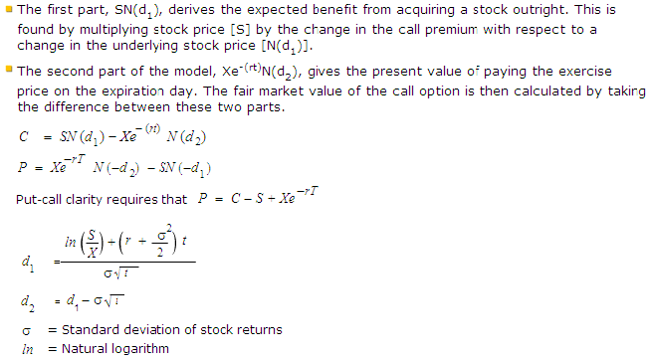

#### Canadian GAAP

Canadian generally accepted accounting principles

#### Capital

➊**Legal** ➋**Regulatory** ➌**Economic** (net value a bank must have at the beginning of the year to ensure that there is only a small probability of defaulting in that year)

#### Capital adequacy

The level of capital that is sufficient to underpin risk and accommodate potential unexpected increases in risk within specified regulatory targets while maintaining our business plans. This includes risks for which minimum regulatory capital requirements may not be specified.

#### Capital position

Measures the extent to which illiquid (long term) assets are funded by short-term liabilities and represents a formula-based measure of mismatches in effective maturity between assets and liabilities including both comparative and directional structural liquidity risk

#### Comprehensive Capital Analysis and Review (CCAR)

Federal Reserve annual exercise ensures that institutions have robust, forward-looking capital planning processes that account for their unique risks and sufficient capital to continue operations throughout times of economic and financial stress. As part of the CCAR, the Federal Reserve evaluates institutions' **capital adequacy**, **internal capital adequacy assessment processes**, and their plans to make **capital distributions**, such as dividend payments or stock repurchases. The CCAR includes a **supervisory stress test** to support the Federal Reserve's analysis of the adequacy of the firms' capital. Boards of directors of the institutions are required each year to review and approve capital plans before submitting them to the Federal Reserve

#### Conditional VaR (CVaR)

Risk assessment technique to reduce the probability a portfolio will incur large losses. This is performed by assessing the likelihood (at a specific confidence level) that a specific loss will exceed the value at risk. CVaR is derived by taking a weighted average between the value at risk and losses exceeding the value at risk. This term is also known as "Mean Excess Loss", "Mean Shortfall" and "Tail VaR".

#### Collateral

Assets pledged as security for a loan or other obligation; many forms: cash, highly rated securities, property, inventory, equipment and receivables. The exposure for counterparty with a collateral agreement is measured as: •Assuming a collateral call is made when the portfolio MTM at certain time node (t) is above the Threshold (T) and Minimum Transfer Amount (MTA). The exposure at time t is calculated **as T+MTA + 10-day close-out exposure (t+10).** •Once collateral call is made, we assume the exposure is reduced down to T+MTA rather than T to add additional layer of buffering for conservative purpose. In reality, the collateral amount called is the MTM amount above T. •Similarly assuming CIBC has to post collateral when the portfolio MTM is below CIBC’s T+MTA. However, the exposure will be brought back to CIBC’s threshold level. •No collateral call/pledge is required if the portfolio exposure is within both counterparty’s and CIBC’s T and MTA. •No collateral call/pledge during the close-out period will be made. •This has been done by inserting a 10-day node to each time node we predefined in the market factor evolution model. In this way, for collateralized counterparty, the simulation and exposure calculation time step is doubled. No simulation on simulation is conducted (nested Monte Carlo) •Constraints in current practice: •Collateral is always assumed to be cash •Cash collateral is assumed to be in USD •Payment or deal expiry during close-out period is not captured •A fixed 10-day close-out period is used across agreements and across products.

#### Collateralized debt obligation (CDO)

Securities with multiple tranches issued by special purpose entities and collateralized by debt obligations including bonds and loans. Each tranche offers a varying degree of risk and return so as to meet investor demand.

#### Collateralized loan obligation (CLO)

Securities backed by a pool of commercial or personal loans, structured so that there are several classes of bonds with varying maturities, called tranches.

#### Commercial mortgage-backed securities (CMBS)

Securities created through the securitization of commercial mortgages.

#### Commitments to extend credit

Unutilized amount of credit facilities available to clients either in the form of loans, bankers’ acceptances and other on-balance sheet financing, or through off-balance sheet products such as guarantees and letters of credit

#### Covered bonds

Full recourse on-balance sheet obligations issued by banks and credit institutions that are also fully collateralized by assets over which investors enjoy a priority claim in the event of an issuer’s insolvency

#### Credit default swaps (CDS)

A derivative contract providing the purchaser with a one-time payment if the referenced entity/entities default (or a similar triggering event occurs)

#### Credit Risk Adjudication

**Credit adjudication units** analyze and evaluate all significant credit requests for corporate and commercial credit exposures, to ensure that risks are adequately assessed, properly approved, continually monitored and actively managed. The decision-making process begins with an assessment of the credit risk of the individual borrower or counterparty. Key factors considered in the assessment include: ⬩Borrower’s management ⬩Borrower’s current and projected financial results and credit statistics ⬩Industry in which the borrower operates ⬩Economic trends; and ⬩Geopolitical risk. Based on this assessment, a ***risk rating*** is assigned to the individual borrower or counterparty, using the Bank’s risk rating systems. A separate risk rating is also assigned at the **facility level**, taking into consideration additional factors, such as security, seniority of claim, structure, term and any other forms of credit risk mitigation that affect the amount of potential loss in the event of a default of the facility. **Security** typically takes the form of charges over inventory, receivables, real estate, and operating assets when lending to corporate and commercial borrowers; and cash or treasuries for trading lines such as securities lending, repurchase transactions, and derivatives. The types of acceptable **collateral**, and related valuation processes are documented in risk management policies and manuals. Other forms of credit risk mitigation include **third party guarantees** and, in the case of derivatives facilities, **master netting agreements**. Internal borrower and facility risk ratings are assigned when a facility is first authorized, and are promptly re-evaluated and adjusted, if necessary, as a result of changes to the customer’s financial condition or business prospects. Re-evaluation is an ongoing process, and is done in the context of general economic changes, specific industry prospects, and event risks, such as revised financial projections, interim financial results and extraordinary announcements. Global Risk Management is the final arbiter of internal risk ratings. The internal credit risk ratings are also considered as part of the Bank’s adjudication limits, as guidelines for hold levels are tied to different risk ratings. Single borrower limits are much lower for higher risk borrowers than low risk borrowers. The credit adjudication process also uses a ***risk-adjusted return on equity profitability*** model to ensure that the client and transaction structure offers an appropriate return for a given level of risk. For the corporate portfolio, and the large borrowers in International, the Loan Portfolio Management Group reviews the profitability model results, together with external benchmarks, and provides an opinion on the relative return and pricing of each transaction above a minimum threshold. Individual credit exposures are regularly monitored by both the business line units and Global Risk Management for any signs of deterioration. In addition, a review and risk analysis of each borrower is conducted annually, or more frequently for higher-risk borrowers. If, in the judgment of management, an account requires the expertise of specialists in workouts and restructurings, it will be transferred to a special accounts group for monitoring and resolution.

#### Credit Risk Creation

Credit originates from primarily two departments: ➊Corporate & Commercial Adjudication (**CCA**) ➋Retail Risk Management

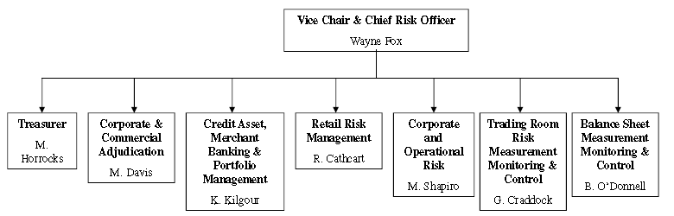

#### Credit Valuation Adjustment (CVA)

Credit value adjustment (CVA) is the difference between the risk-free portfolio value and the true portfolio value that takes into account the possibility of counterparty’s default. In other words, CVA is the market value of counterparty credit risk. **CVA = Expected (average) credit loss from c/p transactions = Expected exposure (mean of distribution of evolution of mark to markets) * Counterparty default probability * LGD** **See CVA**

#### Credit VaR (CVaR)

Consider a credit portfolio that consists of default-sensitive instruments such as lines of credit, corporate bonds, and government bonds. The corresponding credit value-at-risk (VaR), is the minimum loss of next year if the worst 0.03 percent event happens. In another words, 99.97 percent of the time the loss will not be greater than VaR. Note that the credit VaR is measured at the time span of one year and is different from the 10-day convention adopted by market VaR. 0.03 percent is chosen because it is a rating agency standard of granting an AA credit rating ***According to Jorion, banks allocate roughly 60 percent of their regulatory capital to credit risks, 15 percent to market risks, and 25 percent to operational risks***

**Credit Equivalent CE** = mark-to-market MTM + potential exposure PE

**Loan equivalent** **LE** = mark-to-market MTM + expected exposure EE

**Factor-based interim PE (**override) = USD notional * exposure exception factor

**Potential Future Exposure PFE** = maximum of zero and the market value of the portfolio = Maximum exposure under normal market conditions for a future point in time

**Expected Positive Exposure EPE** = weighted average over time of the expected exposure, where the weights are the proportion that an individual expected exposure represents of the entire exposure horizon time interval

#### Derivative

Contract between 2 parties, requiring little or no initial investment and where payments between the parties are dependent upon the movements in price of an underlying instrument, index or financial rate. Examples include swaps, options, forward rate agreements and futures. The notional amount of the derivative is the contract amount used as a reference point to calculate the payments to be exchanged between the two parties, and the notional amount itself is generally not exchanged by the parties.

#### Dividend payout ratio

Common dividends as a percentage of net income after preferred share dividends

#### Dividend yield

Dividends per common share divided by the average of the high and low share prices in the relevant period

#### Duration

Measure the sensitivity of the price (value of principal) of a fixed-income investment to a change in interest rates, i.e. interest rate risk (rate fluctuations); expressed as a number of years. Rising interest rates mean falling bond prices. Calculation involves present value, yield, coupon, final maturity and call features.

##### Effective duration

Effective Duration = V2 - V3 / 2(V1)(∆y)

Where ∆y = change in yield in decimal (∆ = "delta"); V1 = initial price; V2 = price if yields decline by ∆y; V3 = price if yields increase by ∆y

Effective duration requires binomial trees to calculate the ***option-adjusted spread (OAS).***

##### McCauley Duration



Where n = number of cash flows, t = time to maturity, C = cash flow, i = required yield, M = maturity (par) value, P = bond price

##### Modified Duration

Modified duration is a modified version of the Macaulay model that accounts for changing interest rates – thus appropriate to measure a bond’s volatility. It is the approx. percentage change in a bond's price for a 100 basis points change in yield, assuming that the bond's expected cash flow does not change when the yield changes. This works for option-free bonds such as Treasuries but not with option-embedded bonds because the cash flows may change due to a call or prepayment.

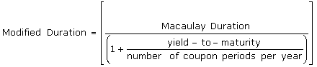

##### Key-Rate Duration

The key-rate duration calculates the spot durations of each of the 11 "key" maturities along a spot rate curve. These 11 key maturities are at the three-month and 1, 2, 3, 5, 7, 10, 15, 20, 25, and 30-year portions of the curve.

Key-rate duration, while holding the yield for all other maturities constant, allows the duration of a portfolio to be calculated for a one-basis-point change in interest rates. The key-rate method is most often used for portfolios such as the bond ladder, which consists of fixed-income securities with differing maturities. ***The sum of the key-rate durations along the curve is equal to the effective duration***

#### Earnings per share (EPS), basic

Net income less preferred share dividends divided by the average number of shares outstanding

#### Earnings per share (EPS), diluted

Net income less preferred share dividends divided by the average number of shares outstanding adjusted for the dilutive effects of stock options and other convertible securities

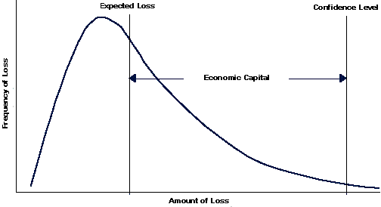

#### Economic capital

An estimate of the amount of equity capital required to underpin risks. It is calculated by estimating the level of capital that is necessary to support our various businesses, given their risks, consistent with our desired solvency standard and credit ratings. The identified risks are **credit**, **market** (trading and non-trading), **operational**, **business**, **fixed asset** and **insurance**. Economic capital also includes **goodwil**l and **intangible**s, and allows for diversification benefits across risks and business segments

**By risk type** ➊**Credit Risk** ➋**Debt Specific Ris**k ➌**Market Risk** ➍**Operational Risk** ➎**Strategic Risk** (strategic failure due to significant investments through acquisition or growth) ➏**Investment Risk** ➐**Customer Behavior Risk** (possible deviations from contractual cash flows due to customer prepayments, liquidations, etc.)

**Parameters** •Time Horizon 1 year • Confidence Level 99.97% •Price Risk Parameters - Time to Reduce and Core Level •Transition Matrix - Credit rating migration probabilities • Expected Loss •Probability of Default: CIBC maps internal ratings to a corresponding expected default frequency (EDF) based on 5 years of historical data •EAD For Large Corporate and Commercial Loans CIBC uses the minimum of 70/80% of a facility and the current usage •LGD defined by internal ratings

**Models** •Market Risk: VaR •Debt Specific Risk: CreditVaR and New DSR Model •Credit Risk –OTC Derivatives –Large Corporate and Commercial Loans –Other **RAROC**

#### Equity Basket Option

A basket option with underlying is a portfolio consisting of a set of stocks or a stock index. The component stocks may belong to a specific sector/industry or a few sectors/industries. Furthermore, the stock portfolio can be constructed so as to replicate a particular market index, wholly or partially. Generally speaking, a section of an index is often used instead of the broader index due to the fact that some component stocks need not necessarily be actively traded on exchanges. The value of an equity basket option is sensitive to the volatility of underlying stocks and the correlation among individual stocks. Equity basket options are normally held by investors who expect a basket of stocks to move substantially during the option's life. To that end, they attempt to avail of the lower premiums on basket options with respect to that on stand-alone options on each component stock.

#### Equity Risk

❶**General Market risk** due Δ stock market indices level (systemic risk not diversifiable) ❷**Specific risk** stock’s price volatility due firm specifics - “unsystematic risk” can be diversified away❸**Vega risk** due Δ underlying volatility

#### Equity Swap

•In an equity swap, 2 parties make series of payments (1 set determined by stock or index return, 1 set as fixed or floating rate or return on another stock or index) •Used to substitute direct transaction in stock ⬩**Applications** ➊Diversifying Concentrated Portfolio ➋Achieving International Diversification ➌Executing an Asset Allocation Decision ➍Create Index Fund ➎Hedging an Equity Position

#### Equity underwriting

#### Equity warehousing

#### Gross adjusted assets (GAA)

For the calculation of the Assets-to-capital multiple; represent total assets including specified off-balance sheet items and net of prescribed deductions. Off-balance sheet items are direct credit substitutes, including letters of credit and guarantees, transaction-related contingencies, trade-related contingencies and sale & repurchase agreements

#### Guarantees and standby letters of credit

Irrevocable assurances that a bank will make payments in the event that its client cannot meet its financial obligations to third parties; Other guarantees, e.g. bid and performance bonds, represent non-financial undertakings

#### Harmonized sales tax (HST)

Canadian sales tax that replaced the federal goods and services tax (GST) and the provincial sales tax (PST) in 5 of 10 Canadian provinces: British Columbia, Ontario, New Brunswick, Newfoundland and Labrador, and Nova Scotia

#### Hedge

A risk management technique used to mitigate exposure from market, interest rate or foreign currency exchange risk arising from normal banking operations. The elimination or reduction of such exposure is accomplished by establishing offsetting positions. For example, assets denominated in foreign currencies can be offset with liabilities in the same currencies or through the use of foreign exchange hedging instruments such as futures, options or foreign exchange contracts

#### Hedge funds

A type of investment fund, marketed to accredited high net worth investors, that is subject to limited regulation and restrictions on its investments compared to retail mutual funds, and that often utilize aggressive strategies such as selling short, leverage, program trading, swaps, arbitrage and derivatives

#### Home equity products

This is comprised of residential mortgages and secured personal loans whereby the borrower pledges real estate as collateral

#### Impaired loans

When there has been a deterioration of credit quality to the extent that management no longer has reasonable assurance of timely collection of the full amount of principal and interest in accordance with the contractual terms of the loan agreement. Credit card balances are **not** classified as impaired as they are directly written off after payments are 180 days past due

#### Innovative capital instruments

Capital instruments issued by Special Purpose Entities (SPEs), whose primary purpose is to raise capital. We previously issued innovative capital instruments, RBC Trust Capital Securities (RBC TruCS) and RBC Trust Subordinated Notes (RBC TSNs), through three SPEs: RBC Capital Trust, RBC Capital Trust II and RBC Capital Trust III. As per OSFI guidelines, innovative capital can comprise up to 15% of net Tier 1 capital with an additional 5% eligible for Tier 2 capital

#### Incremental risk charge (IRC)

Effective in Q1 of 2012, as part of the revisions to the Basel 2.5 frameworks, the IRC is a supplemental market risk capital charge that is intended to capture the credit rating migration and default risk of held for trading positions. We calculate the IRC for all cash and credit derivative positions that attract models-based regulatory capital including sovereign issuers. The implementation of the IRC increased RWA and reduced capital ratios compared to the prior year

#### International Financial Reporting Standards (IFRS)

principles-based standards, interpretations and framework adopted by International Accounting Standards Board

#### Interest Rate Risk

Interest rate risk’s 3 components: term structure risk, basis risk, options risk.

##### Term structure risk

(**Yield curve** or **re-pricing risk**) = risk due to changes in fixed income term structure when maturity mismatches or with floating rate assets/liabilities causing **re-pricing** risks when interest rate is reset—either due to maturities or floating rate resets.

##### Basis risk

**(Spread risk)** = risk due to changes in spreads when lending rate (prime) is different from funding rate (LIBOR).

##### Options risk

Risk due to fixed income options—stand-alone (caps, swaptions) or embedded (callable bonds, prepayment). The market risk of fixed income options arises primarily from 2 sources: changes in underlying interest rates, and changes in implied volatilities, therefore term structure risk (including option risk), and basis risk

#### Interest Rate Swap IRS

•Contractual obligation to exchange series of interest payments (fixed/floating) over predetermined ***swap term*** •For borrowers (most frequent users): ***synthetic fixed rate for fixed term*** •Underlying funding still accomplished through floating rate (such as Bankers Acceptance (“B.A.”)) issuance; client agrees to pay fixed rate & receive floating rate (i.e. borrower continues to fund by Bankers Acceptances or LIBOR and receives that index in return for paying a fixed rate) •Floating index either 1 or 3-month B.A.’s or LIBOR •Cash flows from swap (fixed versus floating rate) netted out •Swap rate effectively represents ***break-even analysis*** of anticipated path of short-term rates implied by yield curve over term of transaction •Any **amortization schedule** (mortgage-style, equal principal payment, roller coaster, etc.) or principal structure •Priced to reflect forward (delayed) start or prior-dated start as appropriate •Cash-settled on “effective date” for utilization as hedge against upcoming debt issuance •Daily weighted average B.A. calculation rather than one-time reset to better emulate cost-of-funds over given period •Accommodate periodic rate setting at end of period rather than beginning - known as “*arrears” structure* (conventionally, rate setting takes place at beginning of period and payment settlement t at end of period) •Incorporate ***B.A. stamping fee*** into fixed rate calculation to create appearance of mortgage-style payments •Established for longer term than underlying credit facility by utilizing **Mutual Puts** (refers to both parties to the transaction having one-day right to terminate the swap with any breakage costs being borne by the out-of-the-money party) •Determination of frequency of periodic swap settlements made in conjunction with client, taking into account conditions imposed by client’s credit agreement with CIBC (requirement for client to make monthly payments of principal and interest will require swap settlement occurs monthly) •Formula to calculate periodic settlement (assuming standard Canadian market conventions): **(Swap Rate - B.A. Rate) * Notional Amount * # of Days in Period / 365 = Settlement Amount** •Positive amounts are debited to client while negative amounts are credited •Assume Fixed Swap Rate of 4.50% and a B.A. Rate of 5.00% at some future point in time on a bullet style swap on a $5,000,000 underlying loan and quarterly resets: (4.50% - 5.00%) * $5,000,000 * 91 days / 365 days = -$6,232.88 - A credit to the clients account of $6,232.88 results in the floating rate interest cost being reset to the predetermined fixed rate interest rate of 4.50% excluding B.A. stamping fee

#### Liquidity Risk

❶**Issues** (liquidity mismatch analysis, market liquidity risk, funding liquidity risk, liquid assets portfolios, collaterals, concentrations, contingent liabilities) •Product coverage with modeling of cash flows, optionality, pricing ❷**Analytics** (gap reports, runoffs, ratios, stochastic analytics, counterbalancing capacity) •Scenario generation, stress testing •Behavioral models of core demand deposits, pre-payable mortgages, mortgage pipeline and revolving facilities, with twin views of contractual and behaviorally modeled cash flows •Stochastic scenario-based dynamic simulation of future business ❸**Functionalities** (cash flow simulation, dynamic behavioral modeling, stochastic & stress scenarios, compliance with regulations, e.g. FSA's Individual Liquidity Adequacy Standards •Scenario-based optimizer to assess earnings & values trade-off

#### Market risk sensitivities

Delta, Gamma, Vega, Theta, Rho **Delta** = NPV of shifted curved –non-shifted curved; shift usually 1 basis point up or down OSFI uses 14-point base curve for calculation **Delta Dollar** represented in dollar - Cash has no **Vega** (for only product with optionality) **Gamma** second derivative of delta

#### Market risk types

❶**Interest Rate risk** ("curve" risk, basis risk) ❷**Commodity** (concentration, liquidity) ❸**FX** (domestic, foreign, spot) ❹**Equity** (general + specific) ❺**idiosyncratic risk, spread risk, cross gamma risk**

#### Market Risk type (and risk factors)

❶**IR** (yield curves, implied volatility of yield, swap spread) ❷**Credit spread** (yield curves, spread curves, FX rates, correlations between indices) ❸**Equity** (stock, index prices, index implied volatilities) ❹**FX** (rate, implied volatilities) ❺**Commodities** (spot, forward, implied volatility, zero) ❻**DSR** (log returns of credit spreads, default/idiosyncratic spread/ downgrade risk) **ENHANCED VAR MEASURES** ➊**IR Basis Risk** (due to changes in spreads, from changes in different market sectors e.g. LIBOR v Prime) ➋**Equity Skew Vega Risk** (due to difference in **implied volatility (IV)** between out-of-the-money, at-the-money and in-the-money options; affected by sentiment and supply/demand relationship; explains preference to write calls or puts; **Vega risk** due to variations in volatility, or volatility of volatility) ➌**Commodity Skew Vega Risk** (skew caused by fear of underlying rallying over underlying falling.) ➍**IR Skew Vega Risk** ➎**Correlation Risk** ➏**Dividend Risk** ➐**Customer Behavior** ➑**Re-pricing Risk**

#### Master netting agreement

Agreement with counterparty designed to reduce credit risk of multiple derivative transactions through creation of a legal right of offset of exposure in the event of a default

#### Monte Carlo Simulation

A broad class of computational algorithms that rely on repeated random sampling to obtain numerical results; typically one runs simulations many times over in order to obtain the distribution of an unknown probabilistic entity

##### Monte Carlo methods

➊Define a domain of possible inputs ➋Generate inputs randomly from a ***probability distribution*** over the domain ➌Perform a ***deterministic*** computation on the inputs ➍Aggregate the results.

##### Normal or “bell curve”

User simply defines the mean or expected value and a standard deviation to describe the variation about the mean. Values in the middle near the mean are most likely to occur. It is symmetric and describes many natural phenomena such as people’s heights. Examples of variables described by normal distributions include inflation rates and energy prices.

##### Lognormal

Values are positively skewed, not symmetric like a normal distribution. It is used to represent values that don’t go below zero but have unlimited positive potential. Examples of variables described by lognormal distributions include real estate property values, stock prices, and oil reserves.

##### Uniform

All values have an equal chance of occurring, and the user simply defines the minimum and maximum. Examples of variables that could be uniformly distributed include manufacturing costs or future sales revenues for a new product.

##### Triangular

The user defines the minimum, most likely, and maximum values. Values around the most likely are more likely to occur. Variables that could be described by a triangular distribution include past sales history per unit of time and inventory levels.

##### PERT

The user defines the minimum, most likely, and maximum values, just like the triangular distribution. Values around the most likely are more likely to occur. However values between the most likely and extremes are more likely to occur than the triangular; that is, the extremes are not as emphasized. An example of the use of a PERT distribution is to describe the duration of a task in a project management model.

##### Discrete

The user defines specific values that may occur and the likelihood of each. An example might be the results of a lawsuit: 20% chance of positive verdict, 30% change of negative verdict, 40% chance of settlement, and 10% chance of mistrial

#### Net interest income

The difference between what is earned on assets such as loans and securities and what is paid on liabilities such as deposits and subordinated debentures

#### Net interest margin (average assets)

Net interest income as a percentage of total average assets

#### Net Interest Income NII, Net Interest Margin, Non-Interest revenues

**Net Interest Income NII = E**arnings on assets (loans + securities) + interests + dividend income – interest expense paid in liabilities (deposits)

Net Interest Margin = NII / earning assets

**Non-Interest revenues** = revenues–NII = securities commissions & fees + deposit & payment services + lending fees + card fees + investment management & custodian fees +mutual fund revenues + underwriting & advisory + Trading-related revenues

#### Normal course issuer bid (NCIB)

Program to repurchase our own shares for cancellation through a stock exchange that is subject to the various rules of the relevant stock exchange and securities commission

#### Notional amount

Contract amount used as a reference to calculate derivatives payments

#### Potential Future Exposure PFE

**Potential Future Exposure** is maximum exposure under normal market conditions for a future point in time **Exposure = MAX(0, MtM)** •PFE is sort of like VaR, but deals with the positive side of the MtM distribution •PFE looks at long holding periods while VaR is for short term fluctuations (default risk usually negligible in the short term)

**Calculating PFE**

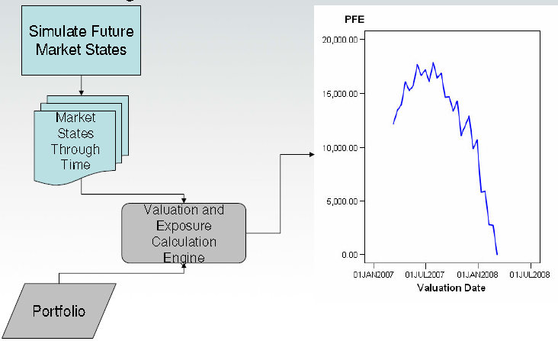

**Issues with Long Dated Simulations** ➊Shape of volatility forward curve ➋Non-normality of price distributions ➌Seasonality of prices and volatility ➍Shifting Correlations

**Simulation Methodology** ➊Modified Covariance Simulation ➋Model Based Simulation

➌**PCA** (Principal Component Analysis Simulation) of Forward Curves

#### Primary sources of risk

❶Incremental VaR (incremental impact of 1 asset) ❷Delta VaR (risk contribution of 1 asset to a portfolio)

#### Productivity ratio

(Most common) expense-to-revenue ratio or cost to revenue ratio measures non-interest expenses as a proportion of operating revenue. Costs include salaries, technology, buildings, supplies, and administrative expenses. Revenue includes net interest income (interest revenue less interest expenses) plus fee income. Cash productivity ratio or cash efficiency ratio - deducts the amortization of intangible assets from noninterest expenses, before calculating the efficiency ratio

#### Off-balance sheet financial instruments

A variety of arrangements offered to clients, which include credit derivatives, written put options, backstop liquidity facilities, stable value products, financial standby letters of credit, performance guarantees, credit enhancements, mortgage loans sold with recourse, commitments to extend credit, securities lending, documentary and commercial letters of credit, note issuances and revolving underwriting facilities, securities lending indemnifications and indemnifications.

#### Office of the Superintendent of Financial Institutions Canada (OSFI)

Primary regulator of federally chartered financial institutions and federally administered pension plans in Canada; OSFI’s mission is to safeguard policyholders, depositors and pension plan members from undue loss

#### Operating leverage

Difference between our revenue growth rate and non-interest expense growth rate

#### Options

A contract or a provision of a contract that gives one party (the option holder) the right, but not the obligation, to perform a specified transaction with another party (the option issuer or option writer) according to specified terms

#### Option-adjusted spread OAS

Option-adjusted spread (OAS) is the flat spread which has to be added to the Treasury yield curve in a pricing model (that accounts for embedded options) to discount a security payment to match its market price. In contrast to the simple **"yield curve spread**" or "**Z-spread"** measurement of bond premium over a fixed cash-flow model, the OAS describes the market premium over a model including two types of volatility: ***variable interest rates*** and ***variable prepayment rates***.

#### Portfolio run-off

Decrease in the assets of a mortgage-backed securities portfolio due to the prepayment of the securities held in that portfolio. It is risk these portfolios face, which can lead to pre-payment risk; this usually forces the fund to reinvest the proceeds at lower yields than where the original securities were purchased. MBS has an embedded call option held by the borrowers of the underlying mortgages backing those securities. When interest rates fall or home values rise, an incentive is created for homeowners to refinance their mortgage, which leads to portfolio runoff for the investors in those mortgages

#### Prepaid pension benefit cost

The cumulative excess of amounts contributed to a pension fund over the amounts recorded as pension expense

#### Primary dealer

A formal designation provided to a bank or securities broker-dealer permitted to trade directly with a country’s central bank. Primary dealers participate in open market operations, act as market-makers of government debt and provide market information and analysis to assist with monetary policy

#### Provision for credit losses (PCL)

The amount charged to income necessary to bring the allowance for credit losses to a level determined appropriate by management. This includes both specific and general provisions

#### RAROC Risk-Adjusted Return on Capital

Single hurdle rate to be used across all businesses to assess performance evaluation

• **RAROC = Net risk-adjusted profit / Economic Capital**

For performance measurement:

• **RAROC = [Revenue – Cost of Funds – Non Interest Expenses – Taxes + Return on E.C. – Expected Credit Losses] / [Credit + Market + Operational + Other Capital]**

#### Repurchase agreements

Involve the sale of securities for cash and simultaneous repurchase of the securities for value at a later date. These transactions do not constitute economic sales and therefore are treated as collateralized financing transactions

#### Residential mortgage-backed securities (RMBS)

Securities created through the securitization of residential mortgage loans

#### Return on common equity (ROE)

Net income less preferred share dividends, expressed as a percentage of average common equity

#### Reverse repurchase agreements

Involve the purchase of securities for cash and the simultaneous sale for value at a later date. These transactions normally do not constitute economic sales and therefore are treated as collateralized financing transactions

#### Risk

Credit risk, market risk, liquidity and funding risk, operational risk, legal and regulatory compliance risk, reputation risk, insurance risk, and strategic risk

#### Risk-weighted assets (RWA)

Assets adjusted by a regulatory risk-weight factor to reflect the riskiness of on and off-balance sheet exposures; certain assets are not weighted, but deducted from capital. The calculation is defined by guidelines issued by OSFI based on Basel II, effective November 1, 2007. Refer to the Capital management section

#### SCD Data Format Setup DFS

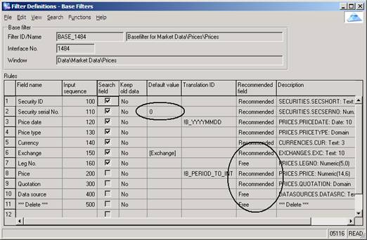

#### SCD Financial Accounting Methods FAM

Approach or formulas used to calculate profit/loss and End-of-Period values. A FAM may be defined using combinations of accounting methods.

#### SCD Financial Accounting Principles FAP

Specifies which fields are significant in the holding key and the appropriate FAM for calculations. FAPs define how many individual calculations should be made, and FAM’s detail how to make those calculations

|  |  |
| --- | --- |
|  |  |

#### SCD Financial Scheme, Financial Account Assignments

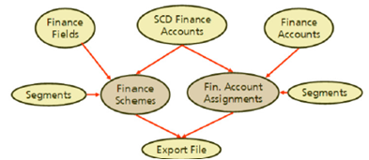

⬩**Finance Account Assignments** not *transaction* but *instrument/ holding key* segmented mappings, to handle account assignment for all transactions meeting various segment criteria (assignment handling all US equities (long/ short/ buys/ sells/ mtm/ dividends/ reclaims) ⬩**Finance Scheme** transaction & instrument specific ⬩Raw transaction values assigned to ***Finance Fields*** mapped to ***Finance Accounts*** via ***Finance Scheme*** setup for ***Agreement Date (AD***) & ***Settlement Date (SD)*** entries; in ***Finance Account Debit/Credit*** columns, Finance Fields assigned to generic ***SCD Finance Accounts*** ⬩***Instrument Segment- Instrument Type- Transaction Segment*** to further segment particular instruments/transactions that can use the scheme; ***transaction segment*** to specify other criteria (long equity versus short equity positions) ⬩In **Finance Account Assignment,** ***Finance Accounts*** mapped into (final internal GL accounts); system allows DR/CR accounts to be configured to depend on sign of amount is +/- (distinguish interest income on positive cash balances from interest expense on negative cash balances ⇨ map Finance Field to generic SCD Finance Account ‘*Interest Inc/Exp*‘ then, based on signage, map +ve amounts to income account and -ve amounts to expense account)

**SCD SIMCORP**🕮 **More on SCD**🕮

#### Securities lending

Transactions in which the owner of a security agrees to lend it under the terms of a prearranged contract to a borrower for a fee. The borrower must collateralize the security loan at all times. An intermediary such as a bank often acts as agent for the owner of the security. Two types of arrangements: lending with and without credit or market risk indemnification. If without indemnification, the bank bears no risk of loss. If with indemnification, it bears the risk of loss if the borrower defaults and the value of the collateral declines concurrently

#### Securities sold short

A transaction in which the seller sells securities and then borrows the securities in order to deliver them to the purchaser upon settlement; at a later date, the seller buys identical securities in the market to replace the borrowed securities

#### Securitization

The process by which various financial assets are packaged into newly issued securities backed by these assets

#### Special purpose entities (SPEs)

May take the form of a corporation, trust, partnership or unincorporated entity; created to accomplish a narrow and well-defined objective with legal arrangements that impose strict limits on the decision-making powers of their governing board, trustee or management over its operations. Frequently these provisions specify that the policy guiding the ongoing activities of the SPEs cannot be modified, other than perhaps by its creator or sponsor

#### Standardized Approach

Risk weights prescribed by OSFI are used to calculate risk-weighted assets for the credit risk exposures. Credit assessments by OSFI recognized external credit rating agencies of S&P, Moody’s, Fitch and DBRS are used to risk weight our Sovereign and Bank exposures based on the standards and guidelines issued by OSFI. Our Business and Retail exposures use OSFI standard risk weights

#### Static P&L or hypothetical P&L

Would have occurred if portfolio at previous day’s close were held constant for current day assuming no additional transactions are made (i.e. ignoring or types of P&L that arise from intra-day trading activities, fees and commissions, and new business revenue)

#### Stress test, scenario analysis

Determine size (not frequency) of potential losses for specific scenarios

#### Structured investment vehicles

Managed investment vehicle that holds mainly highly rated asset-backed securities and funds itself using the short-term commercial paper market as well as the medium-term note (MTN) market

#### Subprime lending

Practice of making loans to borrowers who do not qualify for the best market interest rates because of their deficient credit history. It carries more risk for lenders due to the combination of higher interest rates for the borrowers, poorer credit histories, and adverse financial situations usually associated with subprime applicants

#### Taxable equivalent basis (teb)

Income from certain specified tax advantaged sources is increased to a level that would make it comparable to income from taxable sources. The offsetting adjustment in the tax provision generates the same after-tax net income

#### Tier 1 capital and Tier 1 capital ratio

Tier 1 capital comprises the more permanent components of capital and consists primarily of common shareholders’ equity, non-cumulative preferred shares, the majority of which do not have conversion features into common shares, and the eligible amount of innovative capital instruments. In addition, goodwill and other items as prescribed by OSFI are deducted from Tier 1 capital to determine adjusted net Tier 1 capital

Tier 1 capital ratio = adjusted net Tier 1 capital / risk-weighted assets

#### Tier 2 capital

Subordinated debentures, trust subordinated notes, the eligible amount of innovative capital instruments that could not be included in Tier 1 capital, and an eligible portion of the total general allowance for credit losses, less OSFI prescribed deductions.

#### Total capital and total capital ratio

Total capital is the total of net Tier 1 and Tier 2 capital. The total capital ratio is calculated by dividing total capital by risk weighted assets

#### Tranche

A security class created whereby the risks and returns associated with a pool of assets are packaged into several classes of securities offering different risk and return profiles from those of the underlying asset pool. Tranches are typically rated by ratings agencies, and reflect both the credit quality of underlying collateral as well as the level of protection based on the tranches’ relative subordination

#### Troubled asset workout

Bulk asset transfers + one-off loan sales (low transaction costs + limited risk) to third-party investors, borrowers, guarantors

#### Trust Capital Securities (RBC TruCS)

Transferable trust units issued by special purpose entities RBC Capital Trust or RBC Capital Trust II to raise innovative Tier 1 capital

#### Trust Subordinated Notes (RBC TSNs)

Transferable trust units issued by RBC Subordinated Notes Trust for the purpose of raising innovative Tier 2 capital

#### Value-at-Risk (VaR)

A generally accepted risk-measurement concept that uses statistical models based on historical information to estimate within a given level of confidence the maximum loss in market value we would experience in our trading portfolio from an adverse one-day movement in market rates and prices

##### VaR

Maximum loss not exceeded with a given confidence level over given period of time = a quantile of return distribution”, common confidence level: 95% or 99% **3 components** ❶position measures ❷market data distribution assumptions ❸measurement models - Measure VaR effectiveness compare realized vs. predicted P&L

##### VaR Enhanced VaR

❶**FX basis risk** spread (foreign interest rates implied based on market forward points & domestic interest rates); segregate FX forward IR risk = [risk from IIR changes of base/ domestic CCY (USD) and IR changes of foreign CCY] ❷**Data sources** swap + spot FX rates from MHS, forward points from Bloomberg, IR Delta sensitivities from Voyager ❸**VaR methods** Excel linked to Bloomberg terminal (a) get USD swap rates, foreign CCY swap rates, FX spot rates + forward points, settlement dates for each CCY and each term from Bloomberg (b) calculate implied foreign interest rates + FX basis (c) get FX basis sensitivities for each CCY and term (d) calculate FX basis P&L as product of change in FX basis from previous COB date to COB date and IR delta for CCY/term for last 2 years (e) calculate VaR as 1st percentile of P&L for CCY

##### VaR IRC (incremental risk charge)

Special risk of securitization in trading book (credit risk transformed into market risk) IRC models measure losses due to default and migration at 99.9% CI over 1 year, accounting for liquidity horizons applicable to individual trading positions or sets of positions

##### VaR Stressed VAR

Merge stress testing with VAR, jump/tail effects, fat tail Gaussian volatilities of returns, turbulent market collective behavior, high confidence level (easy), liquidity penalties (hard), idiosyncratic (hard), different time scales for different risks/ environments, dynamic trading effects (model) **Enhanced VaR** = stressed VaR, back testing and stress testing **MtM (mark-to-market) & MC VaR** X(t)= [x1(t),x2(t),…, xn(t)] time series market data, P() trade price function, T current date **MtM** *MtM(T) = P{X(T)}*, *X(T)* spot data; ∀ scenario *s*, trade value ScenValue(s) = P{X(s)} ⇨ P&L(s) = ScenValue(s) - MtM(T) **Historical simulation of X(s)** X(s) = X(T) *shock(s) if relative shock or X(s) = X(T) +shock(s) if absolute shock; shock(s) from historical market data X(t), t<T **Monte Carlo simulation of X(s)** X(s) = F [X(T), a(X(t)), z(s)], F() market data model, z(s) random variable vector, a(X(t)) model parameters estimated from historical market data X(t), t<T

#### Variable interest entity (VIE)

Either does not have sufficient equity at risk to finance its activities without additional subordinated financial support, or where the holders of the equity at risk lack the characteristics of a controlling financial interest

#### FX Trading Private

FX Demand Draft - aka "**remotely created checks**", method used by individuals to make transfer payments from one bank account to another. Demand drafts are marketed as a relatively secure method for cashing checks. The major difference between demand drafts and normal checks is that demand drafts do not require a signature in order to be cashed

FX Overdraft - A revolving facility repayable on Demand, made available in connection with a current account. Money is withdrawn from a bank account and the available balance goes below zero. In this situation the account is said to be "overdrawn". If there is a prior agreement with the account provider for an overdraft, and the amount overdrawn is within the authorized overdraft limit, then interest is normally charged at the agreed rate. If the negative balance exceeds the agreed terms, then additional fees may be charged and higher interest rates may apply

# Data Management

## Data Management Maturity

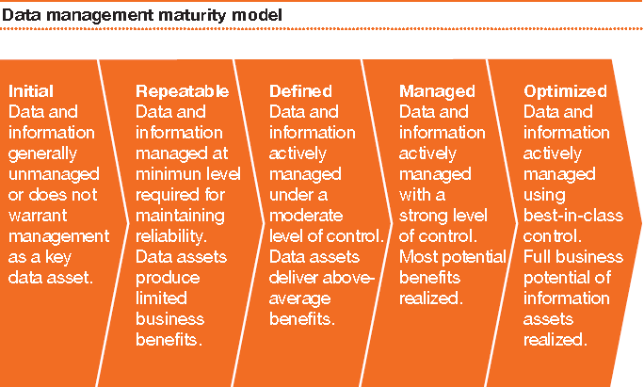

## DARPA data management framework

#### Data Management 11 Knowledge Areas

➊**Data Governance** planning, oversight, control over management of data + use of data and data-related resources ➋**Data Architecture** overall structure of data and data-related resources as an integral part of enterprise architecture ➌**Data Modeling & Design** analysis, design, building, testing, and maintenance ➍**Data Storage & Operations** structured physical data assets storage deployment & management ➎**Data Security** privacy, confidentiality and appropriate access ➏**Data Integration & Interoperability** acquisition, extraction, transformation, movement, delivery, replication, federation, virtualization & operational support ➐**Documents & Content** storing, protecting, indexing, and enabling access to data found in unstructured sources (electronic files and physical records), and making this available for integration and interoperability with structured (database) data ➑**Reference & Master Data** managing shared data to reduce redundancy and ensure better data quality through standardized definition and use of data values ➒**Data Warehousing & Business Intelligence** managing analytical data processing & enabling access to decision support data for reporting and analysis ➓**Meta-data** collecting, categorizing, maintaining, integrating, controlling, managing, delivering meta-data ➊**Data Quality** defining, monitoring, maintaining data integrity, improving data quality

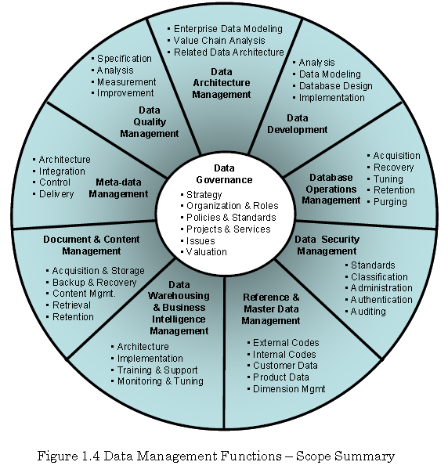

#### Data Management Context diagram

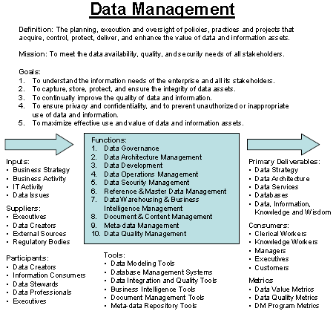

#### Data Governance Context Diagram

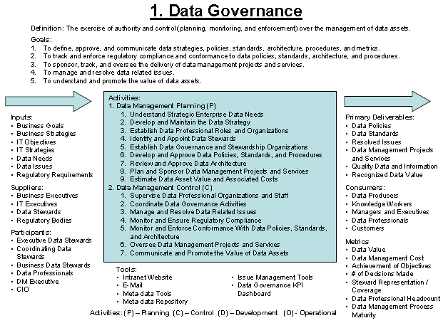

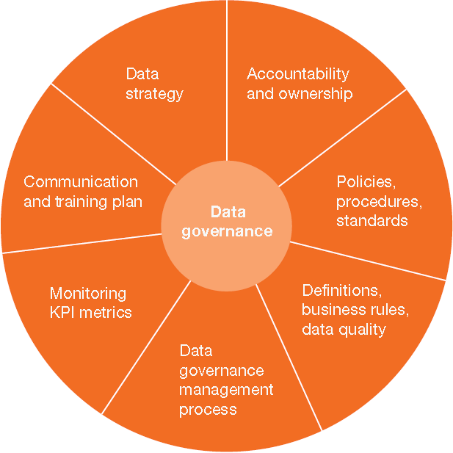

##### Data Governance Framework (DGI)

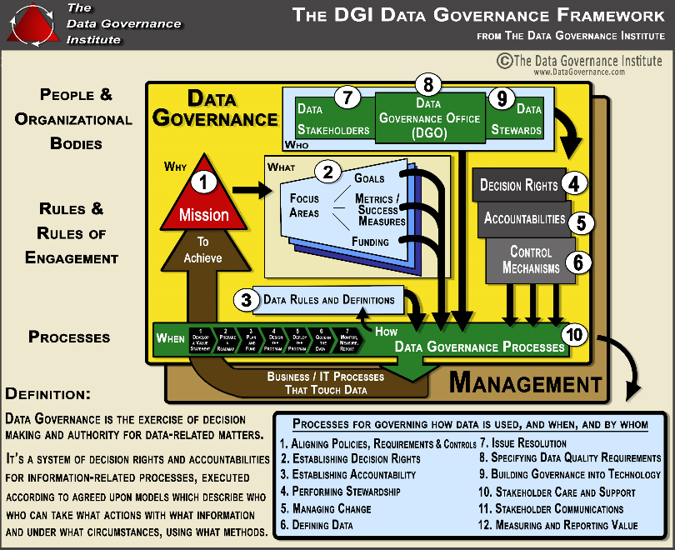

##### 7 Data governance scope

➊**Data Strategy & Policies** (define, communicate, monitor) ➋**Data Standards & Architecture** (review, approve, monitor)) ➌**Regulatory compliance** (communicate, monitor, enforce) ➍**Issue Management** (identify, define, escalate, resolve) ➎**Data management projects** (sponsor, oversee) ➏**Data asset valuation** (estimate, approve, monitor) ➐**Communication** (promote, build awareness, appreciate)

##### Data Governance Decision Spectrum

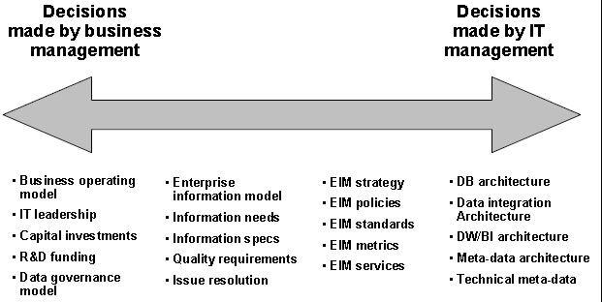

##### Data Governance, Stewardships and Services

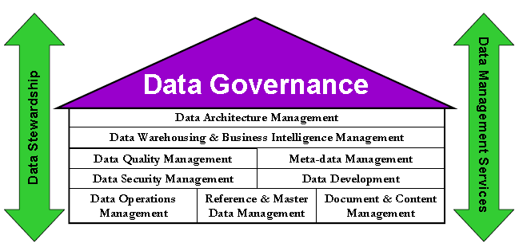

##### Data governance activities

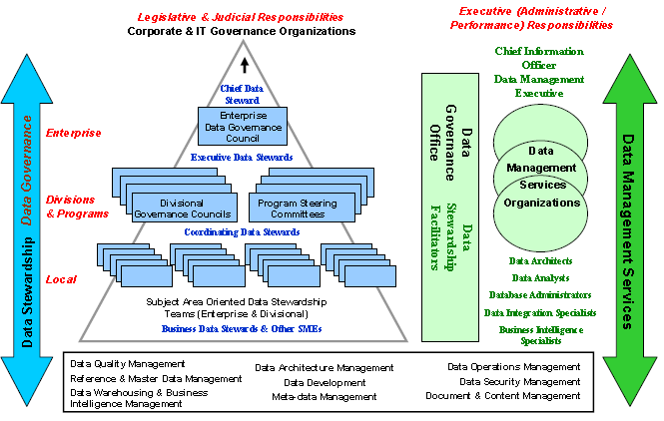

##### Data Strategy (13)

➊Compelling vision for data management ➋Business Case ➌Guiding principles, values, management perspectives ➍Mission, long-term goals ➎Measures for success ➏Short-term (12-24 months) SMART objectives ➐DM organizations, roles, responsibilities ➑DM program components & initiatives ➒Implementation roadmap (projects, action items) ➓Scope boundaries, decisions & issues for postponement ➊**DM Project charter** (vision, business case, goals, guiding principles, success measures, CSF, risks) ➋**DM Scope Statement** (3-year planning horizon goals & objectives, roles, organizations, RACI) ➌**DM Implementation Roadmap** (programs, projects, task assignments, delivery milestones)

##### Data Policies (9)

➊Data modeling, other development activities within SDLC ➋Development and use of data architecture ➌Data & Metadata quality expectations, roles, responsibilities ➍Data Security (confidentiality, intellectual property rights, personal data privacy, access & usage) ➎Data recovery and retention ➏Access & use of external sources ➐Sharing internally, externally ➑DW/BI policies ➒Files/physical records policies

##### Data Procedures (10)

➊Data modeling & architecture standards (data naming, definition, domains, abbreviations) ➋Business & technical meta-data to capture, maintain, integrate ➌Data model management guidelines & procedures ➍Metadata integration & usage ➎DB recovery, business continuity, DB performance, data retention, external data acquisition ➏Data security standards & procedures ➐Reference data management & control procedures ➑Match/ merge, data cleansing standards & procedures ➒BI standards & procedures ➓Enterprise content management standards & procedures (enterprise taxonomies, support for legal discovery, document and email retention, electronic signatures, report formatting standards, report distribution approaches)

#### Data Architecture Management

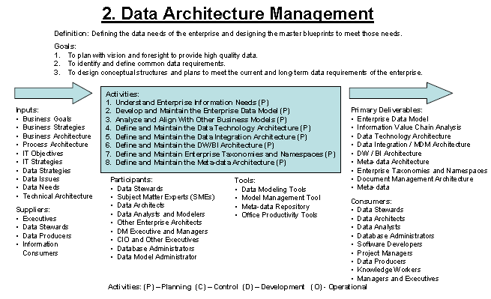

##### Data Architecture Categories (3)

➊**Enterprise Data model** heart & soul of data architecture ➋**Information value chain analysis** align data, business processes, enterprise architecture components ➌**Related data delivery architecture** (DB architecture, data integration architecture, DW/BI architecture, document content architecture, metadata architecture)

##### Enterprise Architecture (6)

➊**Information architecture** business entities, relationships, attribute, definitions, reference values ➋**Process architecture** functions, activities, workflow, events, cycles, products, procedures ➌**Business architecture** goals, strategies, roles, organization structures, locations ➍**System architecture** applications, SW components, interface, projects ➎**Technology architecture** networks, HW, SW, protocols ➏**Information value chain artifacts** relationship (data, process, business systems, technology)

##### Enterprise Data Model

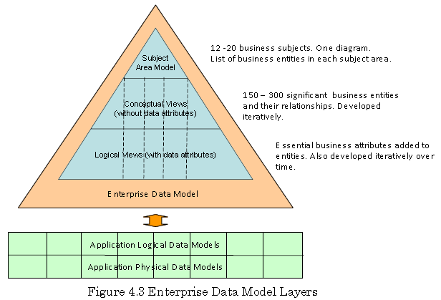

##### Business Value Chain

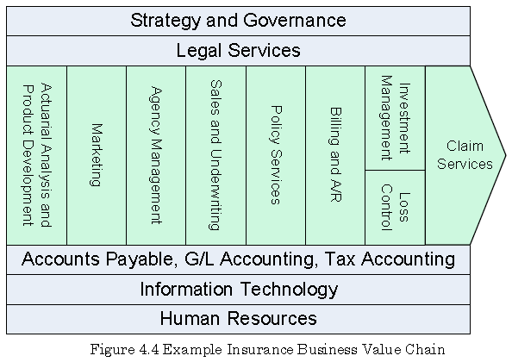

##### Methods to define Enterprise Architecture

* **IBM Business System Planning**
* **James Martin Information System Planning**

##### Zachman Enterprise Framework (6)

➊**Planner View (Scope context)** list of subject areas, business entities ➋**Owner View (Business Concepts)** conceptual data models ➌**Designer View (System Logic**) Fully attributed & normalized logical data model ➍**Builder View (Technology)** physical data models ➎**Implementer View (component assemblies)** data structures, DDL ➏**Functional enterprise actual implemented instances**

##### Normalization levels

⬩**1NF** Entity has valid Primary Key; all elements depend on PK, no repeating groups, atomic (not multi-valued) data element ⬩**2NF** Entity has minimal PK, all elements depend on complete PK ⬩**3NF** No hidden PK, each element depends on no data element outside PK (“*the key, the whole key and nothing but the key*”)

#### Data Development Context Diagram

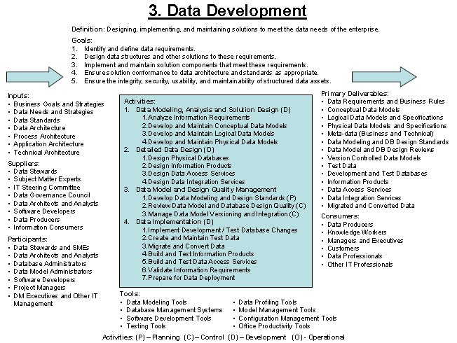

##### Data Lifecycle

|  |  |  |
| --- | --- | --- |
| **Level (from Zachman)** | **Data** | **Function** |
| 0 Scope (contextual) | Relevant to business | Set of business processes |
| 1 Business Model (conceptual) | Semantic Model | Functional Requirements  (Use Case) |
| 2 System Model (logical) | Logical Data Model | Logical Design |
| 3 Technology Model (physical) | Physical Data Model | Physical Design |
| 4 Detailed Representation | Data definition | Program |

###### Deliverables per analysis stage

|  |  |  |
| --- | --- | --- |
| **Analysis Stages** | **Models** | **Language** |
| **1 Business Analysis** | ⬩Business Use cases ⬩Process models ⬩Business data semantics | UML |
| **2 Requirements Analysis** | ⬩Requirement Use Cases ⬩Business data models ⬩Message choreographies | UML |
| **3 Logical Analysis** | ⬩Package & Class Models ⬩Message Sequence Diagrams | UML |
| **4 Logical Design** | Class Models | UML |
| **5 Physical Design** | Program code, XML schema | TBD |

###### Semantics and Business Language

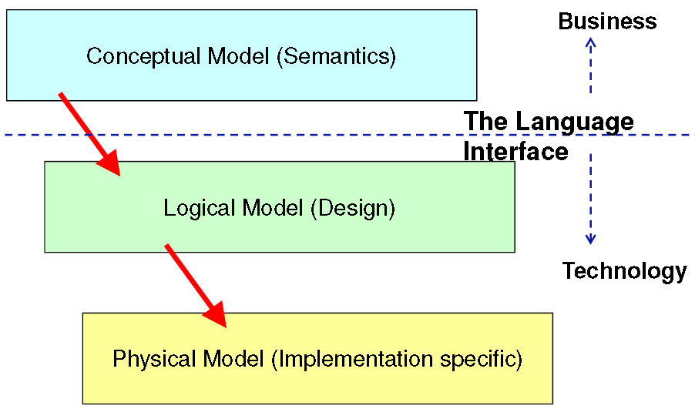

***Semantics*** Relation (signs, things referring to/ meaning) **Requirements for Conceptual Model** owned and validated by business ❶Manage “Language interface” between tech and business SME ❷Everything in English ❸Everything reviewable •Spreadsheets •Dialect-free diagrams **Ontology** = model with [⬩Description of concepts in domain of discourse (i.e. *Classes*) ⬩Properties of each concept (class) describing features & attributes (i.e. *slots, properties, roles*) ⬩Restrictions on those properties (i.e. *facets*)] **Ontology** 🞧 instance of information modeled according to that ontology = **knowledge base** **Ontology** = formal specification of conceptualization ***Taxonomy*** = Structured classification scheme (e.g. Linnaeus Taxonomy of Species, taxonomy of Financial Instruments) ***Ontology*** adds formal properties to **taxonomy**/ describes real world things ***Vocabulary/ Lexicon*** words for things **Resource Description Framework (RDF)** = general-purpose language for representing information in the Web

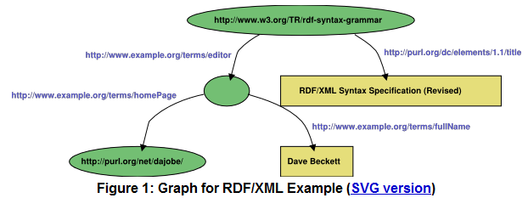

#### Data Operations Management

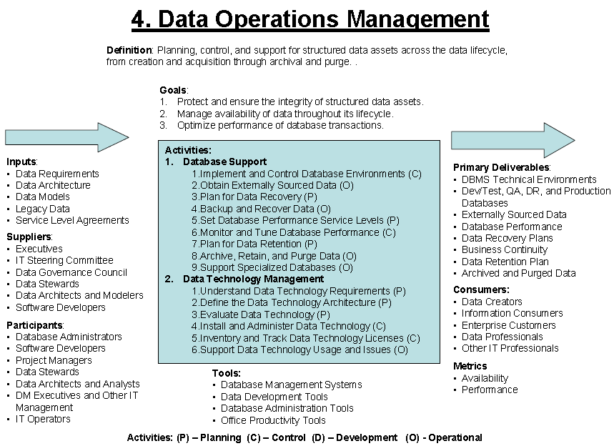

#### Data Security Management

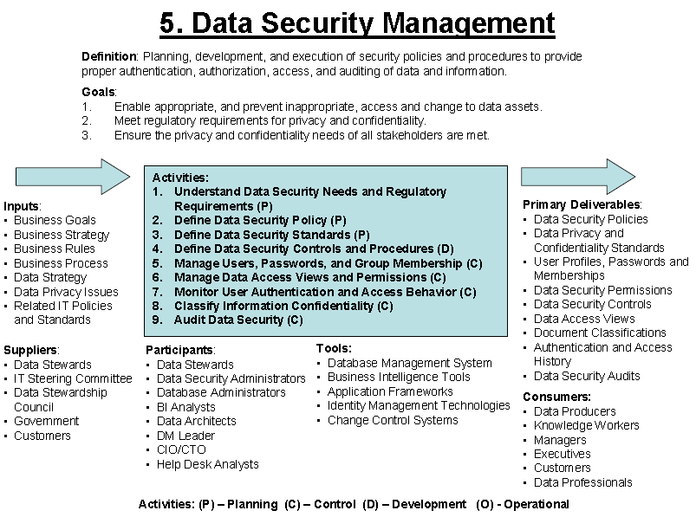

##### Data Security in the outsourced world

➊SLA ➋Limited liability provisions in outsourcing contracts ➌Right-to-audit clauses ➍Consequences to breaching contractual obligations ➎Frequent data security reports ➏Independent monitoring of vendor activity ➐Frequent and thorough security auditing ➑Communication with vendor

#### Reference and Master Data Management

##### Reference Data Management

Control over defined domain values (a.k.a. vocabularies), including: ⬩standardized terms ⬩code values & other unique identifiers ⬩business definition for each value ⬩business relationships within & across domain value lists ⬩shared use of accurate, timely & relevant reference data value to classify and categorize data

##### Master Data Management

Control over master data values for consistent, shared, contextual use across systems

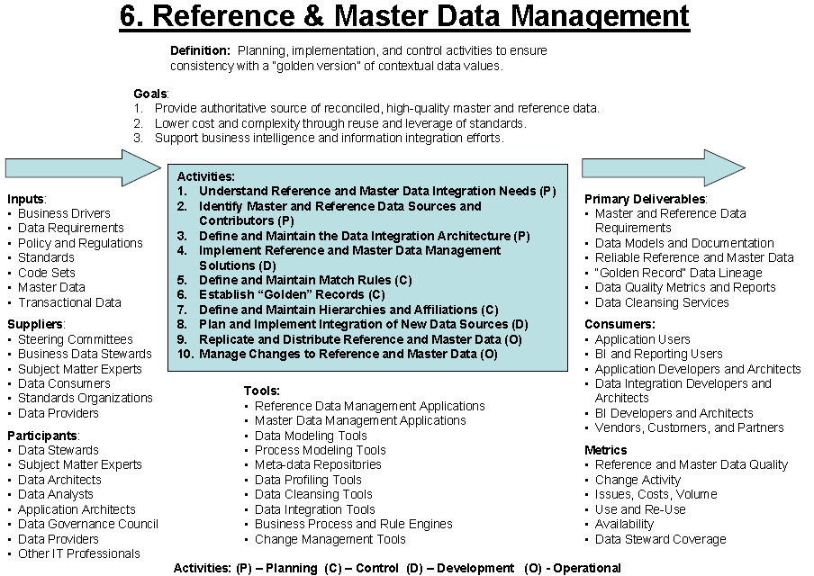

##### Data Integration Architecture

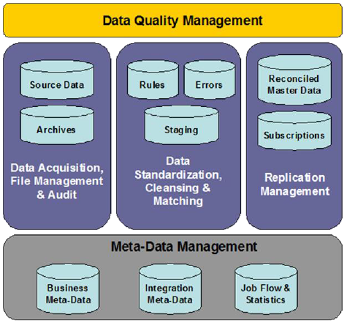

#### Data Warehousing & Business Intelligence Management

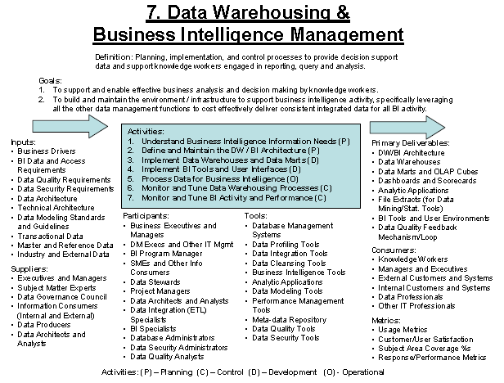

##### Kimball Business Lifecycle

➊**Business Focus** (immediate, long-term) ➋**Atomic Dimensional Data Models** ➌**Iterative Evolution Management**

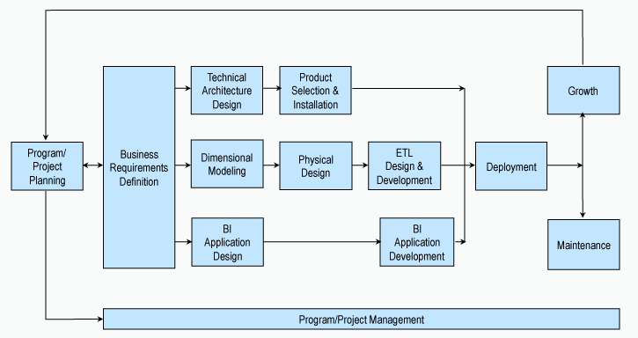

##### Kimball’s data warehouse chess pieces

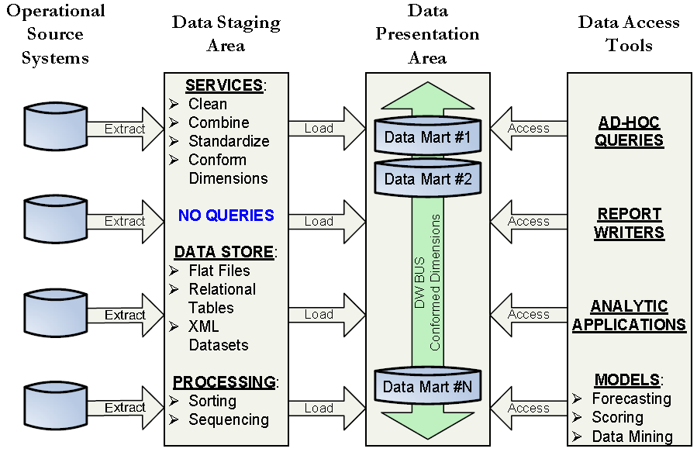

##### BI Level of Complexity

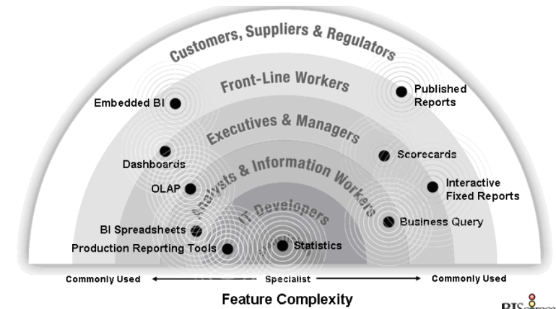

##### Sample data conversion architecture

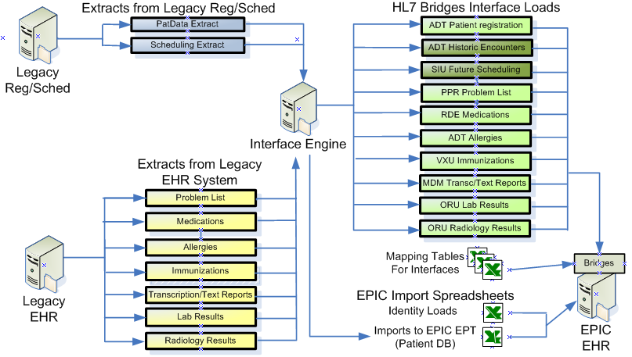

🕮**SIMCORP Data warehouse**

##### Data Warehouse Processes (IBM)

➊Establish project ➋Prepare project ➌Initiate DB ➍Explore DB ➎Implement ➏Iterate/Expand

###### P1 Establish Project

➊**Gain corporate commitment & sponsorship** ➋**Define high-level architecture** ➌**Target opportunities** ⬩**Project attributes** (-source data existing & easily acquired -end users committed -results have immediate value) ⬩**Scope attributes** (- Target single subject area -From 2 to 6 sources at most -From 2 to 4 consumers -Common usage across consumers - Can be achieved in 3-6 months - Incremental investment) ➍**Establish realistic goals** ⬩**IT** (-Build client/server solution skills -8 to 10 data warehouse tables) ⬩**End user** (-Reproduce x, y and z reports from DW -Have at least hard copy metadata -Able to track sales trends for last 12 months by product) ➎**Develop high level project plan** ⬩**Iterative approach** (•Get minimal data through process •Debug process •Add more data/subject areas •Incorporate discoveries into next cycle) ⬩**Timebox (deadlines)**

###### P2 Prepare project

➊**Define key tasks** -Data acquisition -Data Modeling –Operations –Metadata -Tools selection -Support ➋**Gather high-level requirements** ⬩**Business requirements** -Processes involved -Critical success factors -Business entities, attributes, relationships (hierarchical, horizontal) ⬩**Business measurements -**Types of users (executive, novice/casual, analyst, power, developer) -Budget for project ⬩**Technical requirements** - Physical topology HW, SW, network configuration -Logical topology -Source database -Warehouse database issues (data needed, structure, transportation, transformation, cleansing, propagation requirements size and growth, operations (security, availability, automation) ⬩**Assemble team** **Technical** project leaders, design/implement warehouse database, data marts and metadata **Business** SME **Corporate sponsors** **End user** end user tool classes, data access/query, report writers, multi-dimensional database (MDD) management systems, advanced decision support, Executive Information Systems (EIS)

###### P3 Initiate DB

|  |  |
| --- | --- |
| ➊**Gather detailed user requirements/ expectations** ➋**Identify transformation & derivation attributes** ⇨ Effort for ⬩Cleansing/ checking data for validity, consistency, accuracy, correctness, trustworthiness ⬩Mapping/ translation/ consolidating data sources ⬩Calculations for data aggregation/ summarization |  |

➌**Model facts & dimensions** ➍**Architect database** (including metadata) multiple tiers, ROLAP, MOLAP ➎**Design infrastructure** HW, SW, propagation methods/ frequency, availability ➏**Acquire source data** ➐**Populate** data warehouse database

###### P4 Explore (Test) DB

•Identify propagation, preparation dependencies •Monitor end user usage (access patterns and performance) •Tune database & tools for optimal performance (iteration on table design as needed (summarize, aggregate, etc) •Plan & schedule update process/cycle •Define monitoring & control procedures •Define backup & recovery methods •Design archiving & retrieval plans/techniques •Create rollout plan for full implementation

###### P5 Implement

➊Prepare production environment ➋Train users ➌Define/initiate support process ➍Move into production

###### P6 Iterate/Expand

###### Iterative development Application – Data - Infrastructure

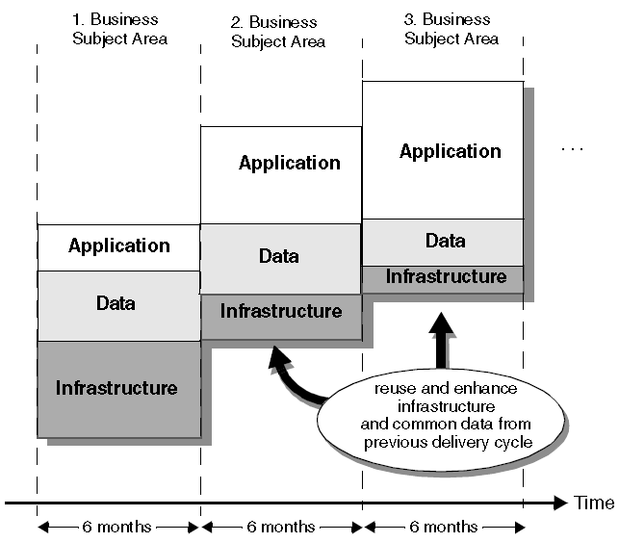

##### Data Warehouse Activities

|  |  |  |  |  |
| --- | --- | --- | --- | --- |
| **Activities** | **Deliverables** | **Responsible** | **Approving** | **Contributing** |
| **Understand BI information needs** | DW-BIM project requirements | Data/BI Analyst, PM, SME | Data Stewart, Executives | Meta-data specialist, Business Process |
| **Define Architecture** | DW/BI Architecture | DW/BI Architect | Enterprise Data Architect, Data Architecture Steering Committee | BI specialists, IT Specialists, Data Integration Specialists, DA, DBA |
| **Implement data warehouse, data marts** | Data warehouse, data marts, OLAP Cubes | BI specialists | DW Architect, Data Stewardship Team | Data Integration Specialists, DA, DBA |
| **Implement BI Tools and UI** | BI Tools & User Environments, Query & Reporting, Dashboards, Scorecards | BI Specialists | DW Architect, Data Stewardship Team, Data Governance | DW Architect, DA, DBA |
| **Process Data for BI (O)** | Accessible Integrated Data, Data Quality feedback | Data Integration Specialists | Data Stewards | DA, DBA |
| **Monitor & Tune DW processes** | DW Performance Reports | DBA, Data Integration Specialists |  | IT Operators |
| **Monitor & Tune BI activity & performance** | BI performance reports, new indexes, new aggregations | BI Specialists, DBAs, BI Analysts |  | DA, DBA, IT Operators, Auditors |

#### Document and Content Management

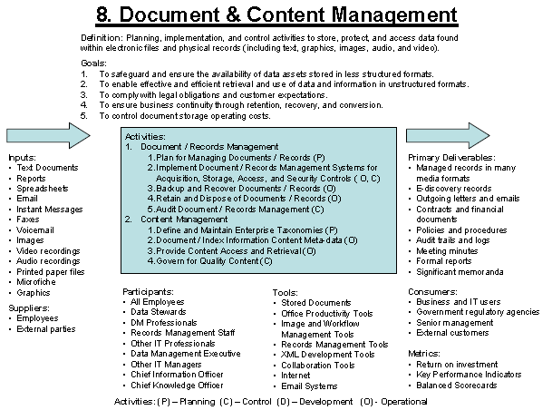

##### ANSI 859 Documents Controls

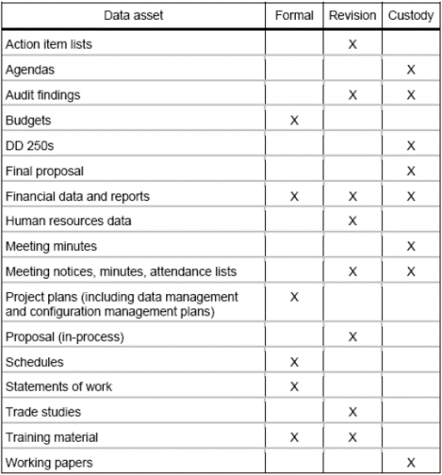

#### Meta Data Management

##### 16 Meta data subject areas

➊**Business Analytics** data definition, reports, users, usage, performance ➋**Business Architecture** roles & organizations, goals & objectives ➌**Business Definition** terms & explanations for concepts, facts ➍**Business Rules** calculations, derivations ➎**Data governance** policies, standards, procedures, programs, roles, organizations, stewardship assignments ➏**Data Integration** sources, targets, transformations, lineage, ETL workflows, EAI, EII, migration, conversion➐**Data quality** defects, metrics, ratings ➑**Document content** management unstructured data, documents, taxonomies, ontology, name sets ➒**IT Infrastructure** platforms, networks, configuration, licenses ➓**Logical data model** entities, attributes, relationships & rules, business names & definitions ➊**Physical data model** files, tables, columns, views, business definitions, indexes, usage, performance, change management ➋**Process models** functions, activities, roles, inputs/outputs, workflow, business rules, timing, stores ➌**Systems portfolio & IT governance** databases, applications, projects, programs, integration roadmap, change management ➍**Service oriented architecture (SOA) information** components, services, messages, master data ➎**System design & development** requirements, designs, test plans, impact ➏**System management** data security, licenses, configuration, reliability, service levels

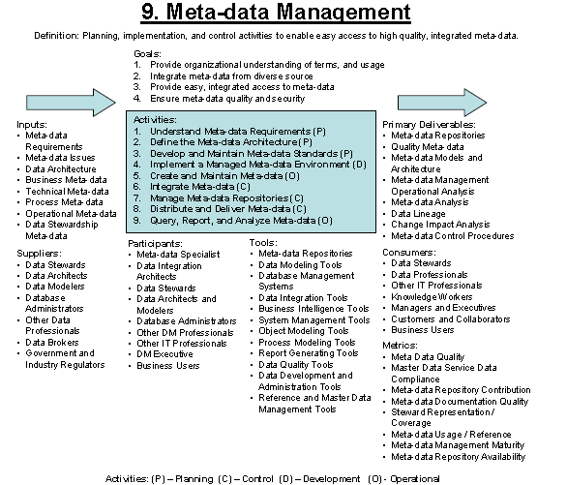

##### Business Meta Data (13)

➊Business data definitions, calculations ➋Business rules, algorithms, hierarchies ➌Data lineage, impact analysis ➍Data model enterprise, conceptual, logical ➎Data quality statements (confidence, completeness indicators) ➏Data stewardship information & owning organizations ➐Data update cycle ➑Historical data availability ➒Historical/ alternate business definitions ➓Regulatory/ contractual constraints ➊Reports list & data contents ➋System of record for data elements ➌Valid value constraints

##### Technical & Operational Meta Data (15)

➊Audit controls & balancing information ➋Data archiving & retention rules ➌Encoding/ reference table conversions ➍History of extracts & results ➎Identification of source system fields ➏Mappings, transformations, statistics for system of record to data stores (OLTP, OLAP) ➐Physical data model (data table names, keys, indexes) ➑Program job dependencies, schedule ➒Program names, descriptions ➓Purge criteria ➊Recovery & backup rules ➋Relationships data models, data warehouse, marts ➌System of record feeding target data stores (OLTP, OLAP, SOA) ➍User report/ query access patterns, frequency, execution time ➎Version maintenance

##### Process Meta Data (10)

➊Data stores & data involved ➋Government/ regulatory ➌Organization owners, stakeholders ➍Process dependencies, decomposition ➎Process feedback loop documentation ➏Process name ➐Process order, timing ➑Process variations due input/ timing ➒Roles, responsibilities ➓Value chain activities

##### Data Stewardship Meta data (11)

➊Business drivers/ goals ➋Data CRUD rules ➌Data definition business/ technical ➍Data owners ➎Data sharing rules, agreements, contracts ➏Data stewards, roles, responsibilities ➐Data stores/ systems involved ➑Data subject areas ➒Data users ➓ Government/ regulatory ➊Governance organization structure/ responsibilities

##### Meta Data Standard

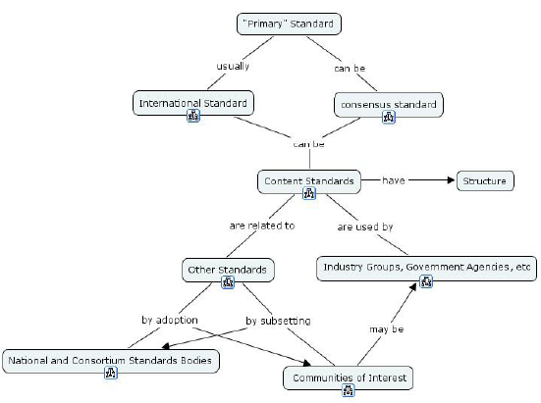

##### Metadata Products & Services 4 requirements

❶Data quality & Integration ➋Standard business information ➌Identifiable and traceable data ➍Data availability

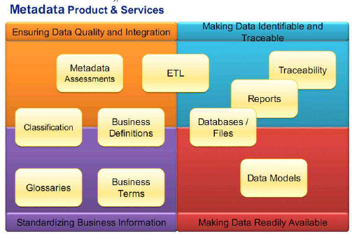

#### Data Quality Management

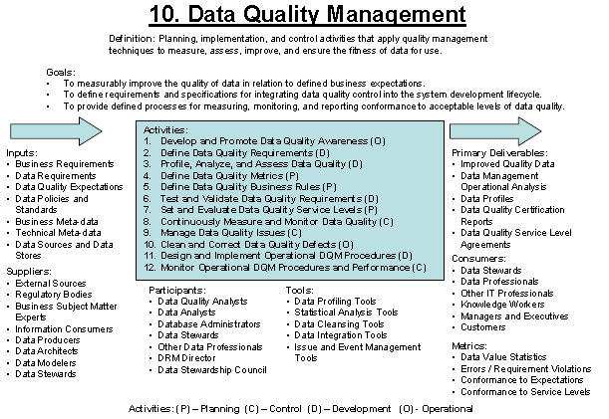

##### Database Quality Dimensions

➊Process ➋Data ➌Semantic ➍Behavior

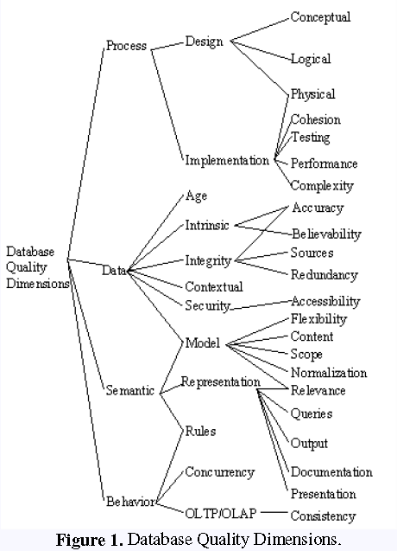

###### Tools

From HYPERCUBE

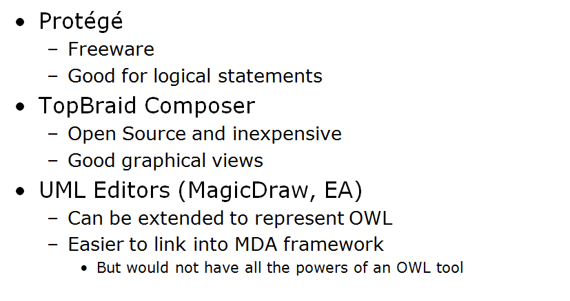

Apache’s HADOOP, MapReduce (MR), HBase

##### Data Quality Dimensions

➊**Accuracy** – Degree data correctly represents ‘real-life’ entities; measured by how values agree with identified reference source ➋**Completeness** a) Attributes always have assigned value b) All appropriate rows present c) Encompasses usability & appropriateness – ***completeness rules***: constraint-mandatory attributes, conditionally optional values, inapplicable attribute values ➌**Consistency** - Data values in one set consistent with other set (e.g. no conflict in values from separate sets); predefined constraints or rules between values of attributes across records or messages; *record-level consistency*, *cross-record consistency*, *temporal consistency* ➍**Currency** – How current with modeled world? Fresh, correct (time-wise); measured as function of expected refreshment frequency; define data lifetime before expiry and update ➎**Precision** – detail level, numerical accuracy ➏**Privacy** – access control + usage monitoring ➐**Reasonableness** – for consistency expectation e.g. # transactions < 105% of running average # transactions for previous 30 days ➑**Referential Integrity** – unique identifier as foreign key, constraints against duplication ➒**Timeliness** - time expectation for accessibility, availability e.g., measured by time between expectation and actual availability ➓**Uniqueness** – only 1 entity within a data set, 1 key value relates to 1 unique identity; more achievable level of controlled redundancy ➊**Validity** - Conformance to data type, precision, format patterns, use of predefined value enumeration, domain ranges, underlying storage formats (different from ***accuracy***)

##### Data Quality Metrics

➊**Measurability** ➋**Business Relevance** ➌**Acceptability** (thresholds acceptable by business) ➍**Accountability** (business owner) / **Stewardship** (corrective action) ➎**Controllability** (undesirable range reflects uncontrolled aspect of business thus triggering corrective action) ➏**Trackability** (quality improvement over time, measure SLA, ensure predictability of continuous data quality)

##### DOD Guidelines on Data quality management

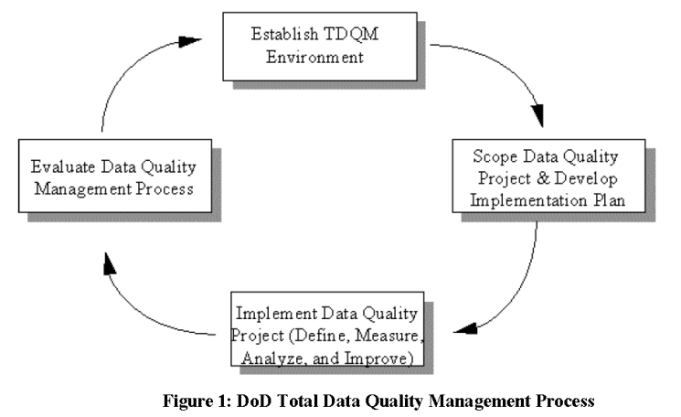

➊**Establish DQM environment** a) **Strategic Plan** (quality goals, objectives, action plans, strategies and projects to achieve data quality goals and objectives, measurable data quality objectives) b) **Cultural environment** (organizational responsibilities for improving data quality, training programs and/or initiatives within functional areas, opening lines of communication between functional experts) ➋**Scope project and implementation plan** a) Identify DQM projects b) develop implementation plan ⧫Task Summary ⧫Task Description ⧫Project Approach ⧫Schedule ⧫Deliverables: reports, products, **Data Quality Baseline Assessment** (current data quality problems, exception reports), **After Action Report** (improvements, rationale, improvement metrics) ⧫Resources, costs ➌**Implement DQM project** (define, measure, analyze, improve) a) **Define** Identify data quality requirements and establish data quality metrics b) **Measure** conformance with established business rules and develop exception reports c) **Analyze** Verify, validate, and assess the causes for poor data quality and analyze opportunities for improvement d) **Improve** change data entry procedures, update data validation rules, data standards for uniform representation of data

➍**Evaluate DQM project**

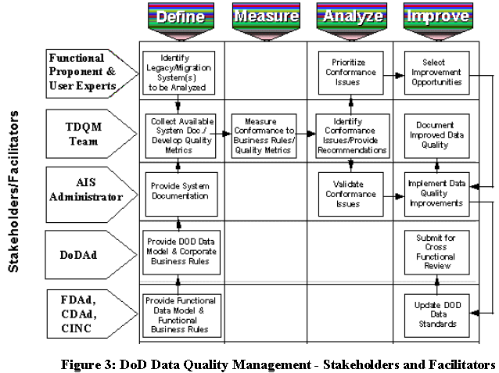

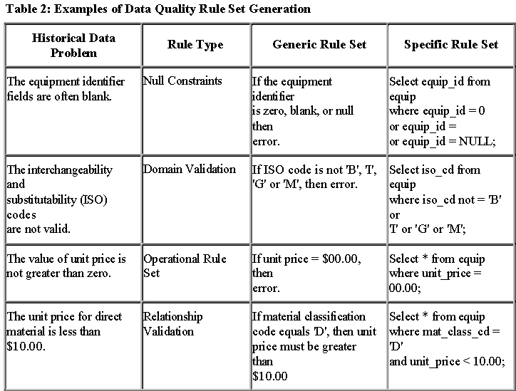

# Service Management

**Skills & Experiences in Service Management & IT Governance**

#### ITIL Infrastructure

❶Service strategy [❷Service Design ❸Service transition ❹Service operation] ❺Continued service improvement

##### Core Topics

|  |  |  |  |  |
| --- | --- | --- | --- | --- |
| **Service Strategy (SS)** | **Service Design (SD)** | **Service Transition (ST)** | **Service Operation (SO)** | **Continued Service Improvement (CSI)** |
| * Service management * Service life cycle * Service assets & value creation * Service provider types & structures * Strategy, markets, offerings * Financial management * Service portfolio * Demand management * Organizational design, culture, development * Sourcing strategy * Service automation & interfaces * Strategic tools * Challenges & risks | * Balanced design * Requirements, drivers, activities, constraints * Service oriented architecture * Business service management * SD models * Service catalogue * Service level * Capacity and availability * Service continuity * Information security * Supplier management * Data & information management * Application management * Roles & tools * Business impact analysis * Challenges & risks * SD package * Service acceptance criteria * Documentation * Environmental issues * Process maturity | * Goals, principles, policies, context, roles, models * Planning, support * Change management * Service asset, configuration management * Release deployment * Service validation, testing * Evaluation * Knowledge management * Communication, commitment * Stakeholder management * Configuration management * Staged introduction * Challenges & risks * Asset types | * Balance in SO * Operational health * Communication * Documentation * Events, incidents, problems * Request fulfillment * Access management * Monitoring & control * IF & service management * Facilities & data centre management * Information & physical security * Service desk * Technical, IT operations, application management * Roles, responsibilities, organizational structures * Technology support to SO * Managing changes, projects, risks * Challenges * Competency guidelines | * Goals, methods, techniques * Organizational change * Ownership * Drivers * Service Level management * Services measurement * Knowledge management * Benchmarks * Models, standards, quality * 7-step improvement * ROI, business issues * Roles * Authority matrices (RACI) * Support tools * Implementation * Governance * Communication * Challenges & risk * Innovation, correction, improvement * Best practices |

##### ITIL Mapping V2 (ITIL LITE) and v3

|  |  |  |  |  |
| --- | --- | --- | --- | --- |
| Service Strategy (SS) | Service Design (SD) | Service Transition (ST) | Service Operation (SO) | Continued Service Improvement (CSI) |
| Financial management | Service level management | Change management | Incident management | Service Improvement |
| Service Portfolio management | Availability management | Service asset & configuration management | Problem management | Service measurement |
| Demand management | Capacity management | Release & Deployment management | Service Desk | Service Reporting |
| Strategy Generations | IT Service continuity management | Transition planning & support | Request fulfillment |  |
|  | Service catalog management | Service Validation & testing | Access management |  |
|  | Information Security management | Evaluation | Event management |  |
|  | Supplier management | Knowledge management | Technical management |  |
|  |  |  | IT Operations management |  |
|  |  |  | Application management |  |

Service Support Service Delivery V3 Components

#### ITIL Strategic questions

➊**Organizational goals, success metrics** ▪Which has **consistent exec level visibility** through reports, meetings, and customer forums? a. Client Retention / Loyalty / Satisfaction b. Competitive Customer Service / Interaction Capabilities c. Frequency and Types of Customer Interaction d. Employee Satisfaction e. Cost of contact center based Customer Interaction f. Client Complaints g. Client Escalation h. Other (Please specify) ➋**New products or services** over the next years ▪Which information from Support Center(s) is used in **decision making**➌**Client profile** ➍**Client interaction** ▪Which **documented processes, documented responsibilities** (a. Establish Customer and Call Center/Help Desk Agent Identity b. Establish Customer Interaction Objective c. Address Customer Interaction Objective d. Close Interaction e. Escalate Interaction f. Transfer Interaction/Conference g. Identify and Address Customer Complaint h. Collecting Demographic/Survey Information) ➎**Metrics** (a. Performance b. Service Quality c. Productivity d. Cost & Control) ➏**Organizational management** (Recruitment, training, appraisal) ➐**Infrastructure** ➑**Operations** ➒**Formal process** (a. Incident Management b. Problem Management c. Change Management d. Service Level Management)

•**ITIL service** = {assets, requirements, people, process} => Deliverables •**Operate, react, improve** = {incident management, asset lifecycle management, change management)

#### ITIL v3

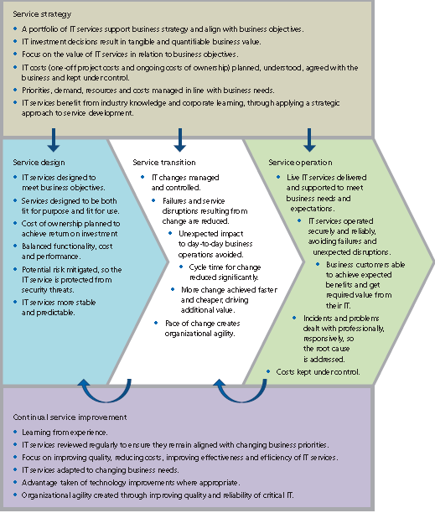

### Service Design

#### Service Design Scope

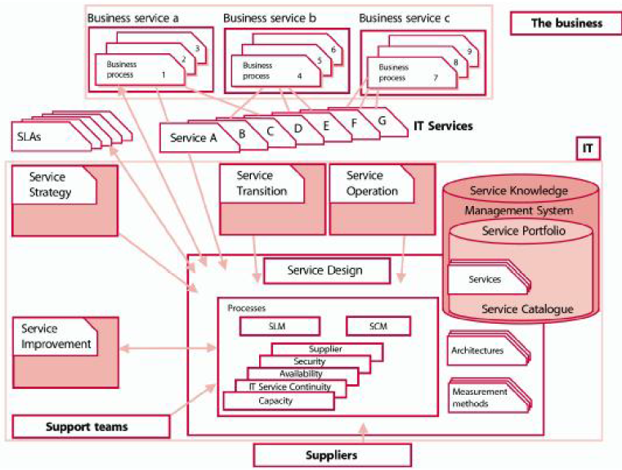

#### Service Design Big Picture

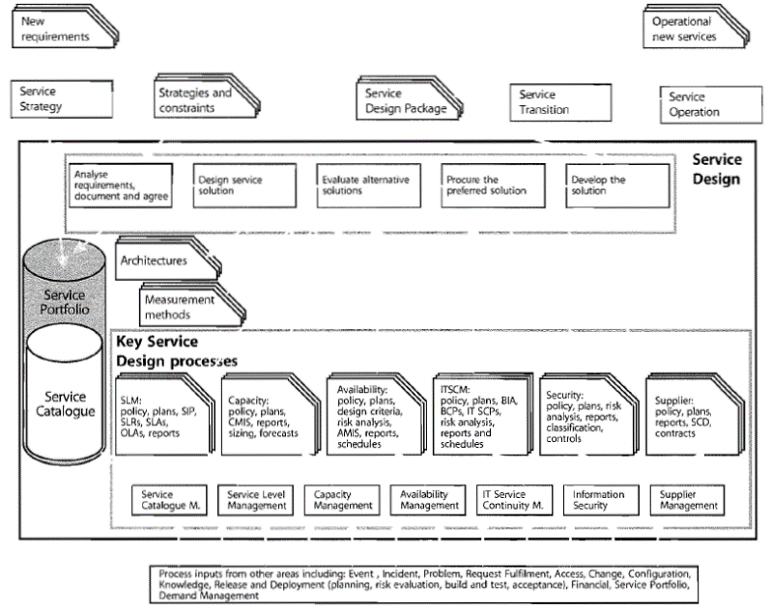

###### Key Processes

➊Service Catalogue Management ➋Service Level Management ➌Capacity Management ➍Availability Management ➎IT Service Continuity Management ➏Information Security Management ➐Supplier Management

###### Service Components

➊Service Catalogue Management ➋Business Process ➌Service ➍Infrastructure ➎Environment ➏Data ➐IT Service Continuity Management ➑Applications ➒Support Services ➓OLA and contracts ➊Support Teams ➋Suppliers

###### Service Level Agreement SLA

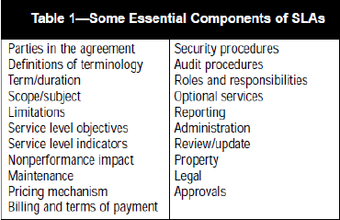

###### Service Requirements

➊Facilities & functionality requirements ➋Business processes, dependencies, priorities, criticality and impact ➌Business cycles and seasonal variations ➍Management information ➎Service management information ➏Service transaction volume ➐Business transaction levels, service transaction levels, users numbers & types

###### SLR (requirements), SLA, OLA

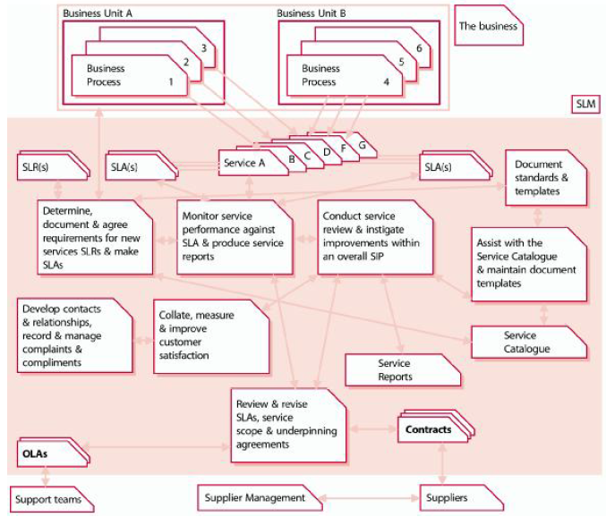

###### Alignment Services to Business Requirements

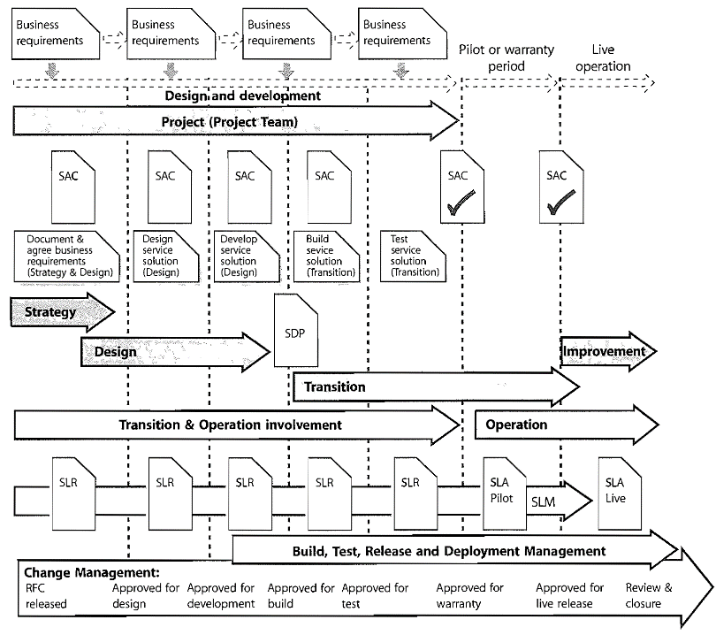

**SAC** = Service Acceptance Criteria **SDP** = Service Design Package

###### Service Level Definition CSF, KGI, KPI

###### 

#### Service Portfolio, Service Catalogue

**Service Portfolio** = Service Pipeline + Catalogue + Retired Services

**Service Portfolio** **Information** = Service name, description, status, classification and criticality, applications used, data/ data schema used, business process supported, business owners, business users, IT owners, service warranty level, SLA and SLR references, supporting services, supporting resources, dependent services, supporting OLAs, contracts & agreements, service costs, service charges, revenues, service metrics

|  |  |
| --- | --- |
|  |  |

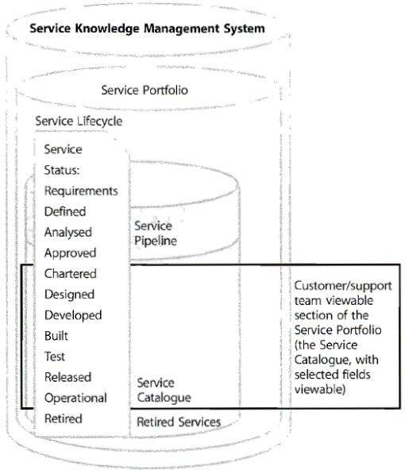

###### Service architecture, Enterprise architecture

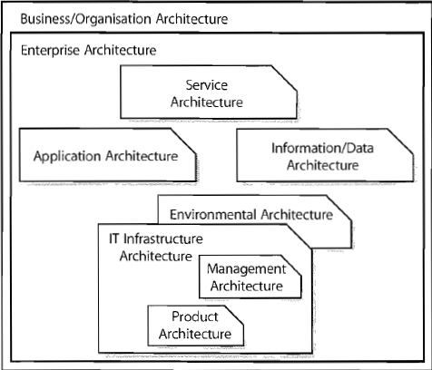

###### Metrics Tree

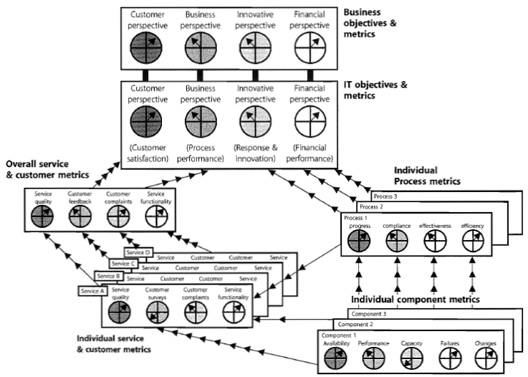

###### Service Catalogue Management

⬩Service definition ⬩Maintenance ⬩Interfaces, dependencies, consistencies (catalogue - portfolio) ⬩Interfaces, dependencies (catalogue – Configuration Management CM)

**Service Catalogue** = Business Catalogue + Technology Catalogue

###### Service catalogue example

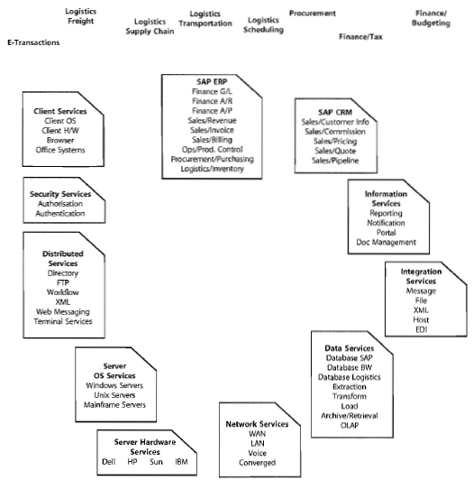

#### Service Level Management

➊Define, document, agree, monitor, measure, report, review IT service level ➋Provide, improve relationship communication with business & customers ➌Monitor, improve customer satisfaction ➍Ensure unambiguous expectation of service level ➎Proactive measures to improve, reduce costs

##### SLM processes

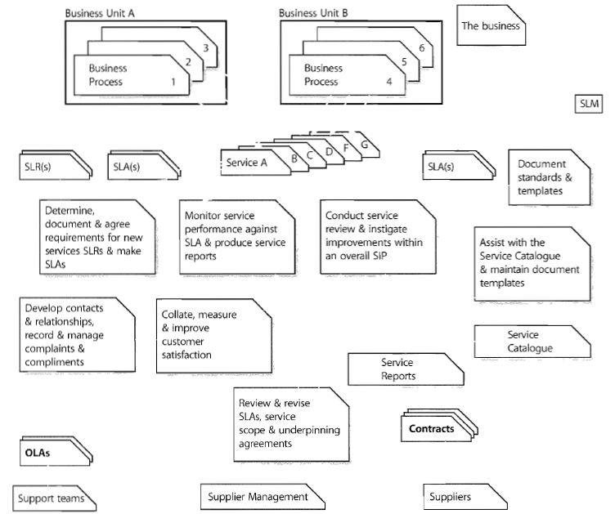

##### Inputs, Outputs, KPI, CSF

|  |  |
| --- | --- |
| **Inputs**  ⬩Business information (strategy, plan, financials, requirements) ⬩Business Impact Analysis (impact, priority, risk, # users) ⬩ Business requirements ⬩Strategies, policies & constraints ⬩Service Portfolio & Catalogue ⬩Change information ⬩CMS (relationships business services, supporting services, technology) ⬩Customer, user feedback, complaints, compliments ⬩Inputs from incident management, capacity management and availability management | **Outputs**  ⬩Service reports ⬩Service Improvement Plan (SIP) ⬩Service Quality Plan ⬩Template SLA, SLR, OLA ⬩SLA ⬩SLR ⬩OLA ⬩Service Review meeting minutes ⬩SLA review and service scope review ⬩Revised contracts |
| **KPI**  ⬩Number or percentage of service targets being met ⬩Number and severity of service breaches ⬩Number of services with up-to-date SLAs ⬩Number of services with timely reports and active service reviews | **CSF**  ⬩Manage overall quality of IT services required ⬩Deliver services at affordable costs ⬩Manage interface with business and users |

#### Capacity Management

##### Capacity Management Information System (CMIS)

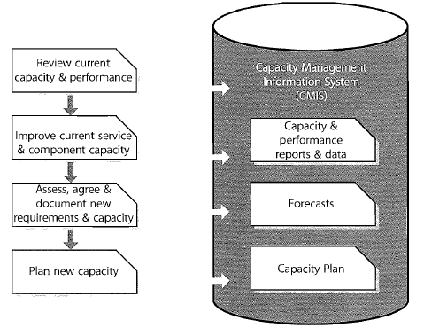

##### Inputs, Outputs, KPI, CSF

|  |  |
| --- | --- |
| **Inputs**  ⬩Business information (strategy, plan, financials, requirements) ⬩Service & IT Information ⬩Component performance & capacity information ⬩Service Performance Issues ⬩Service Information ⬩Financial, change, performance information ⬩CMS (relationships business services, supporting services, technology) ⬩Workload info | **Outputs**  ⬩**Capacity Management Information System (CMIS)** ⬩Capacity Plan ⬩Service Performance Information & Reports ⬩Workload analysis & reports ⬩Ad-hoc capacity & performance report ⬩Forecasts & predictive reports ⬩Thresholds, alerts and events |
| **KPI**  ⬩Accurate business forecasts ⬩Knowledge of current, future technologies ⬩Demonstrated cost effectiveness ⬩Matching capacity to business needs | **CSF**  ⬩Same as KPI |

#### Availability Management

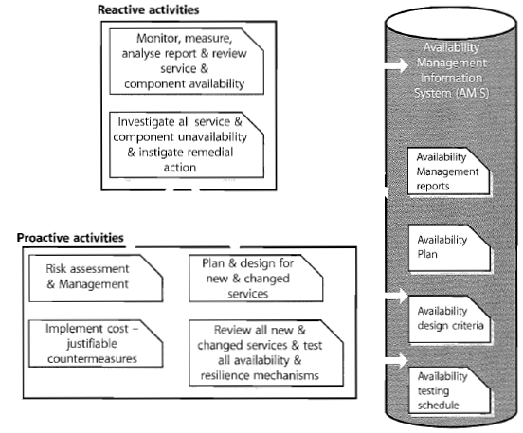

##### Availability

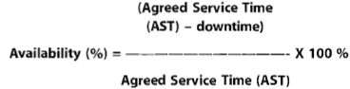

##### Reliability



**MTBSI** = Mean Time between Service Incidents **MTBF** = Mean Time between Failures

##### Maintainability



**MTRS** = Mean time to restore service

##### Incidents Life Cycle

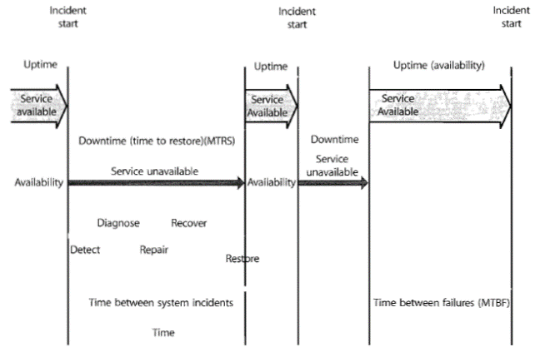

#### Service Continuity Management

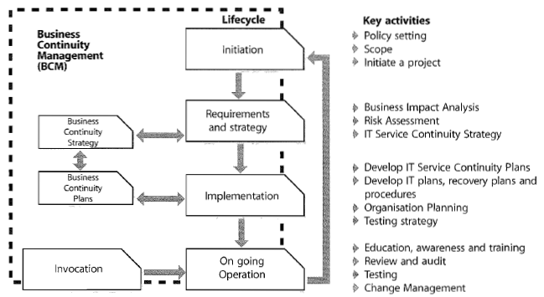

##### Business Impact Analysis (BIA)

|  |  |
| --- | --- |
|  |  |

##### Management of Risk (M_O_R)

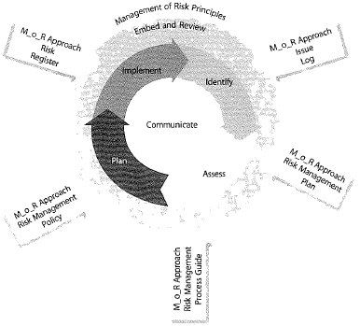

##### Plans to include with BCP

|  |  |
| --- | --- |
|  |  |

#### Information Security Management

##### Framework

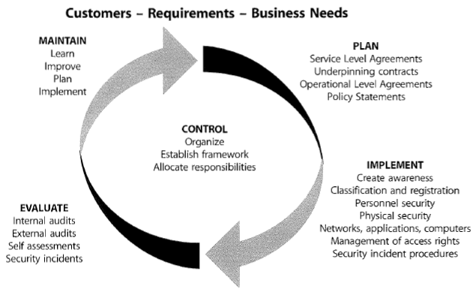

|  |  |
| --- | --- |
|  |  |

##### Security Policies

|  |  |
| --- | --- |
|  |  |

##### Process

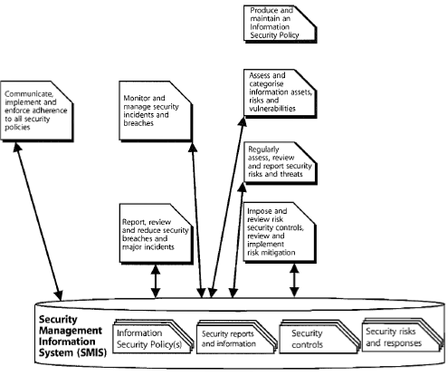

##### Controls for threats

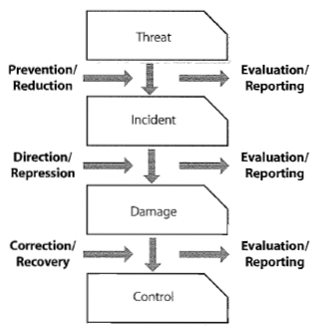

### Service Delivery

##### Service Desk

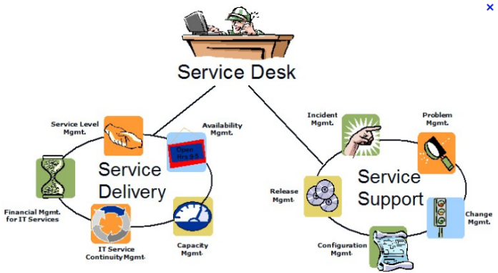

###### Service Desk guidelines

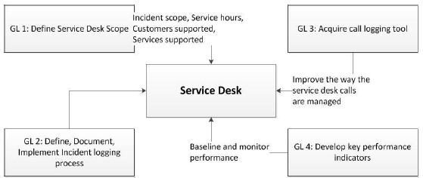

###### Incident Management

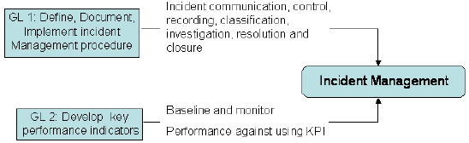

###### Problem Management

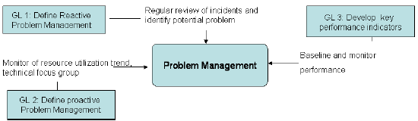

###### Change Management

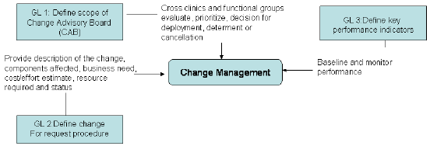

##### End-to-end Service

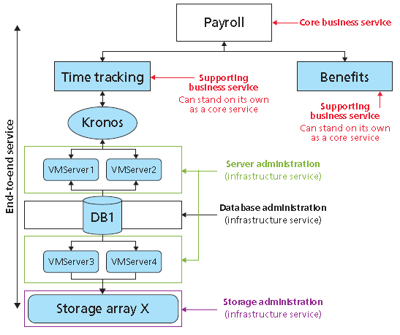

##### ITIL Service Delivery processes

➊Service Level Management ➋IT Financial Management ➌Capacity Management ➍Availability Management ➎IT Service Continuity Management

###### ITIL Service Level Management SLA, OLA, UC

•**SLA (Service Level Agreement)** –written agreement between service provider and the Customer, that documents agreed Service Levels for a Service, not legal contract!

• **OLA (Operational Level Agreement)** –internal agreement covering the delivery of services which support the IT organization in their delivery of services, not legal contract!

• **UC (Underpinning Contract)** –contract with an external supplier covering delivery of services that support the IT organization in their delivery of services, legal contract!

###### SLA Template

➊Objective(s) of the SLA ➋Focus of the SLA ➌SLA reporting periods ➍Validation triggers ➎Monitoring frequency ➏Escalation process (◦Thresholds ◦Actions)

###### OLA Template

➊**General Overview** ➋**Service and Charges** 2.1-Scope 2.2-Charges (if applicable) 2.3-Service Dependencies & Underpinning Contracts 2.4-Assumptions ➌**Parties Responsible** ➍**Service Provider Requirements** (Roles and Responsibilities) ➎**Incident and Service Request Processing** 5.1-Service Requests [Work Requests (if applicable), Standard Service Requests, Non-standard Service Requests/Ad-hoc Work Requests] 5.2-Service Change Request 5.3 Incident Management [Normal Incident Processing, Major Incident Handling] 5.4 Problem Management 5.5 Service Maintenance/Change Management 5.6 Service Exceptions ➏**Reporting**

###### Lifecycle of Service Continuity Management

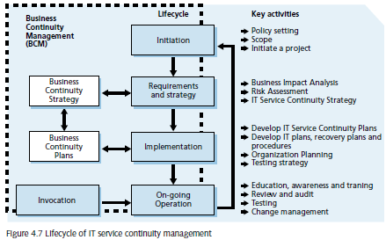

###### Resource Management Infrastructure

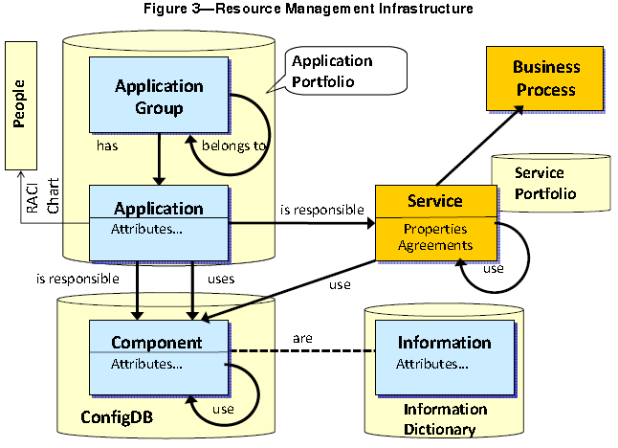

###### ITIL Implementation with BMC Remedy

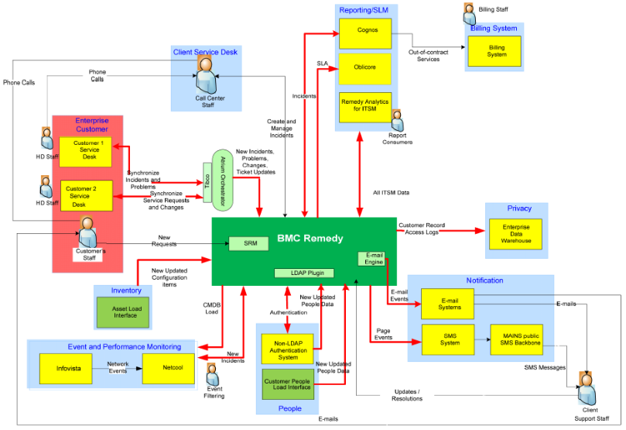

#### Microsoft Operations Framework (MOF)

Based on **ITIL v2** - While ITIL deliberately aims to be platform-agnostic, MOF is designed by Microsoft to provide a common management framework for its products. Microsoft has mapped MOF to ITIL as part of their documentation of the framework.

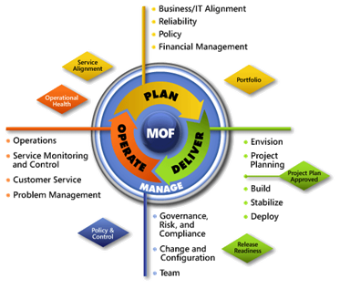

# IT Governance

##### COBIT 4 domains

➊Plan & organize ➋Acquire & implement ➌Deliver & support ➍Monitor & evaluation

##### COBIT 5

|  |  |
| --- | --- |
|  | 🕮**COBIT 5**  ⬩COBIT 5 processes now cover end-to-end business and IT activities, i.e., a full enterprise-level view ⬩COBIT 5 follows same goal & metric concepts as COBIT 4.1, Val IT and Risk IT, now renamed enterprise goals, IT-related goals & process goals reflecting an enterprise level view. |

##### COBIT Components

##### 

##### COBIT Domains and Processes

|  |  |
| --- | --- |
| I**-PLANNING & ORGANISATION**  1.0 Define a Strategic IT Plan  2.0 Define the Information Architecture  3.0 Determine Technological Direction  4.0 Define the IT Org. & Relationships  5.0 Manage the IT Investment  6.0 Communicate Mgt Aims & Direction  7.0 Manage Human Resources  8.0 Ensure Compliance with Ext. Requirmnts  9.0 Assess Risks  10.0 Manage Projects  11.0 Manage Quality  **II-ACQUISITION & IMPLEMENTATION**  1.0 Identify Automated Solutions  2.0 Acquire and Maintain Application SW  3.0 Acquire and Maintain Tech Infrastructure  4.0 Develop and Maintain Procedures  5.0 Install and Accredit Systems  6.0 Manage Changes | **III-DELIVERY & SUPPORT**  1.0 Define and Manage Service Levels  2.0 Manage Third-Party Services  3.0 Manage Performance and Capacity  4.0 Ensure Continuous Service  5.0 Ensure Systems Security  6.0 Identify and Allocate Costs  7.0 Educate and Train Users  8.0 Assist and Advise Customers  9.0 Manage the Configuration  10.0 Manage Problems and Incidents  11.0 Manage Data  12.0 Manage Facilities  13.0 Manage Operations  **IV-MONITORING & EVALUATION**  1.0 Monitor the Processes  2.0 Assess Internal Control Adequacy  3.0 Obtain Independent Assurance  4.0 Provide for Independent Audit |

##### COBIT Relationship of Business Areas

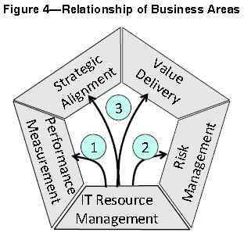

##### COBIT Interdependence of IT Resources



## FI 3 Lines of Defense

➊Controls in place for day-to-day business➋Committees & functions in place for oversight to effectively operate internal control framework ➌Independent assurance from committee of non-executive directors & internal audit function that reports to that committee



 